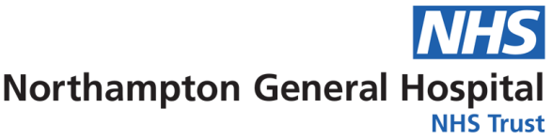
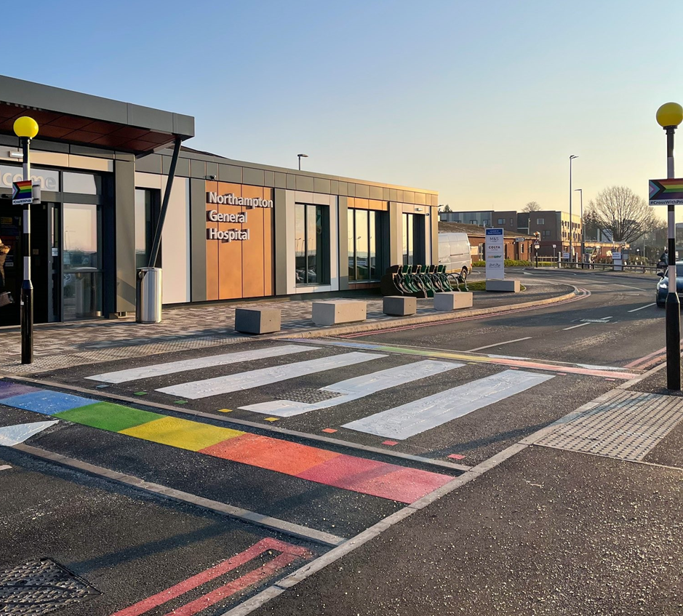
Equality, Diversity & Inclusion
Workforce Annual Report
April 2022 to March 2023
Equality and Diversity

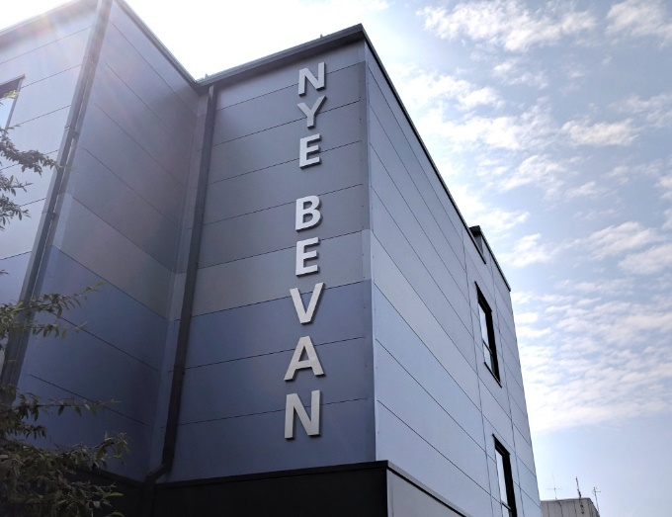
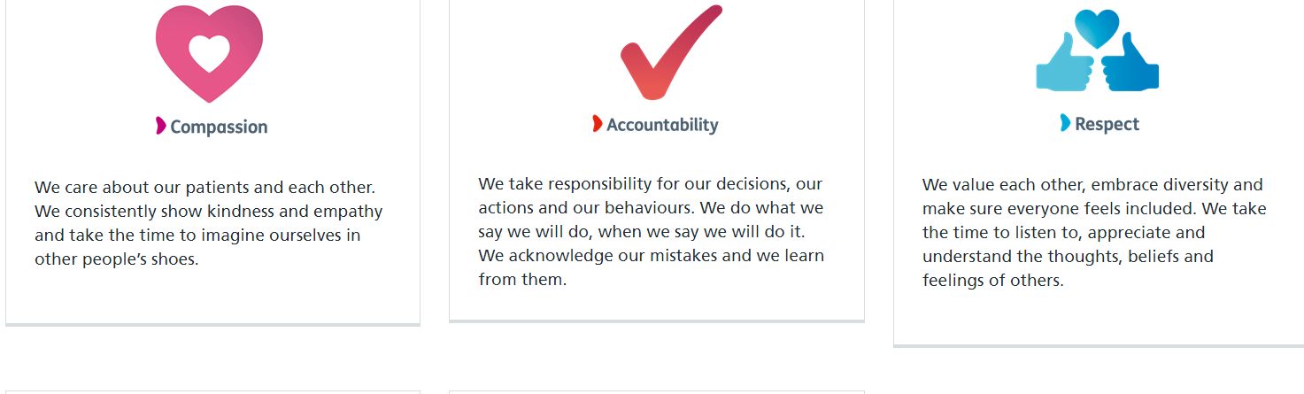
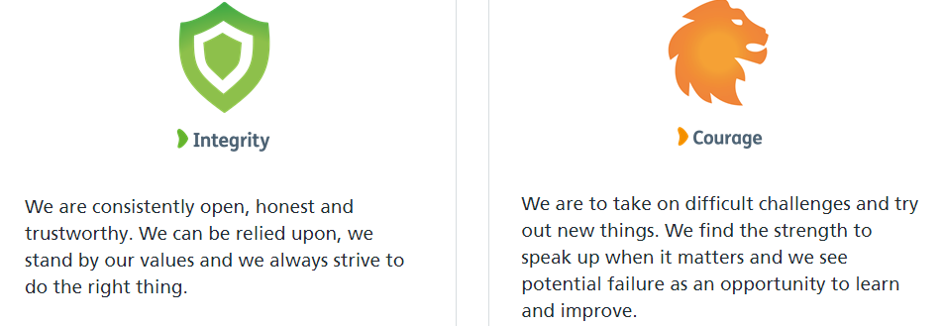
Contents
Our Vision, Mission and Excellence Values
Our Vision is - Dedicated to outstanding patient care and staff experience by becoming a University Hospital Group and a leader in clinical excellence, inclusivity and collaborative healthcare.

Our Mission is - To provide safe, compassionate and clinically excellent patient care, by being an outstanding employer for our people, by creating opportunities, supporting innovation, and by working in partnership to improve local health and care services.

Executive Summary 4

Introduction – Our Strategic Aims 5
2022/202 Summary 6

Our Population 7

Our Activities 8
Our Colleagues 14

Executive Summary

The Equality, Diversity and Inclusion Workforce Annual Report for 2022/2023 reviews the work Northampton General Hospital (NGH) has undertaken to promote equality, celebrate diversity create an inclusive workforce during April 2022 to March 2023.

Northampton General Hospital and Kettering General Hospital form the University Hospitals of Northamptonshire NHS Group which will enable us to work more closely together to provide our colleagues with a great place to work, which in turn, enables us to meet our Mission, Vision and Values during 2022/2023 and the years ahead.

In July 2021 we approved our 2021-24 Group Equality, Diversity & Inclusion Strategy, providing a real focus on the work that the Trust needs to undertake as part of its commitment to become a truly inclusive employer for our people and our patients.

We are determined and committed to improve the experiences of teams by driving the necessary changes for people to truly be united in making NGH the best it can be – a place where people feel valued, respected and empowered. We want to work to make sure we keep the amazing staff we have and support them to implement change and feel valued at work, where they can bring their whole selves to work and be celebrated for everything they are.

We are also committed to encouraging our teams to think differently and explore ideas with them on how we can make NGH the best place to work and receive care. We have established a number of staff networks to ensure that we celebrate and embrace the diversity of teams. Our REACH (Race, Ethnicity & Cultural Heritage), DAWN (Disability & Wellbeing Network), PRIDE (LGBTQ+) and VOICE (NGH Women in Medicine) networks all support colleagues to have their voices heard and provide a space for us to all learn and improve how we do things here.

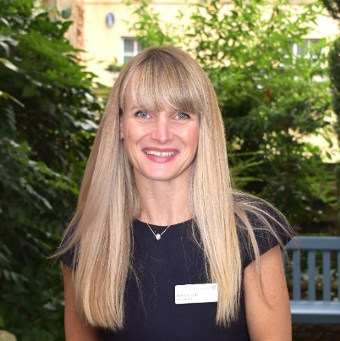

Heidi Smoult Alan Burns
Hospital CEO Chairman

Introduction – Our Strategic Aims

Equality, Diversity, and Inclusion (EDI) are key to achieving the Group vision of being “Dedicated to excellence in patient care and staff experience, and to becoming a leader in clinical excellence, inclusivity and collaborative healthcare.”

We believe that the Equality, Diversity, and Inclusion agenda is critical to building a future proof workforce that is truly reflective of the diverse communities we serve. We also believe that in building a diverse workforce, we will increase the talent pool from which we recruit and build services that are responsive to the needs of the local community.

We have agreed five priorities for the Group. Everything we do across both Northampton General Hospital NHS Trust and Kettering General Hospital NHS Foundation Trust should contribute towards achieving goals within at least one of these priority areas. They represent the long-term objectives of the Group, and each has an ambition and a success measure that we can track. Every year we will analyse our performance as a Group and set annual goals designed to make the biggest impact on each of these areas. Delivering our goals will move us closer towards achieving our overall vision.

- Patient - Excellent patient experience shaped by the patients' voice.
- Quality - Outstanding quality healthcare underpinned by continuous, patient-centred improvement and innovation.
- Systems and Partnerships - Seamless, timely pathways for all people's health needs, working together with our partners.
- Sustainability - A resilient and creative University Hospital Group, embracing every opportunity to improve care.
- People - An inclusive place to work where people are empowered to make a difference.

Further information regarding Equality, Diversity and Inclusion can be found on our website at Equality, Diversity & Inclusion (northamptongeneral.nhs.uk)

Summary of our Activities

Audit
Completed the first EDI Network audit in which chairs could have a forum to discuss their experiences of the EDI framework and help improve the structure.
Sunflower Badges
Purchased 200 Sunflower Badges for clinical staff. Badges are to replace lanyards while continuing to support staff with Hidden Disabilities

Training
Overhaul of Mandatory EDI training in line with national guidance. Utilising local providers to provide specific LGBTQ+ training for colleagues
Inclusion Networks
Continued to work with and expand our Inclusion Networks by appointing two new chairs for our PRIDE & DAWN Networks

Workforce Race Equality Standard (WRES)
Data collection undertaken and analysed for action planning on areas for improvement in conjunction with REACH group
Workforce Disability Equality Standard (WDES)
Data collection undertaken and analysed for action planning on areas for improvement in conjunction with DAWN group

Northampton Pride
Participated at Northampton Pride where staff networks engaged with members of the public on improving services for LGBTQ+ individuals
Policy Review
Begun work on reviewing Trust policies to be more inclusive of current workforce population. Policies currently under review: Disciplinary, Transgender

Our Population

NGH provides general acute services for a population of 380,000 and hyper-acute stroke, vascular and renal services to people living throughout the whole of Northamptonshire, a population of 692,000. The Trust is also an accredited cancer centre and provides cancer services to a wider population of 880,000 who live in Northamptonshire and parts of Buckinghamshire.

In addition to the main hospital site, which is located close to Northampton town centre, the trust also provides outpatient and day surgery services at Danetre Hospital in Daventry. The principal activity of the Trust is the provision of free healthcare to eligible patients. We are a hospital that provides the full range of outpatients, diagnostics, inpatient and day case elective and emergency care and also a growing range of specialist treatments that distinguishes our services from many district general hospitals. We also provide a very small amount of healthcare to private patients.

West Northants Population (2021 Census)

Age Group | Ethnic Group | Religion | Sex
0-20  23.7% | White  85.9% | Christian 49.5% | Male  49.5%
21-25  5.6% | Asian  5.3% | Muslim  3.5% | Female  50.5%
26-30  6.4% | Black  4.9% | Hindu  1.3%
31-35  7.2% | Mixed  2.8% | Buddhist  0.4%
36-40  7.0% | Other  1.1% | Sikh  0.4%
41-45  6.7% |  | Jewish  0.1%
46-50  6.7% |  | Other,  (inc no religion or not stated)  44.9%
51-55
7.1%
56-60
6.8%
61-65
5.6%
66-70
4.7%
71+
12.5%

Our Activities

During 2022/23 we continued to work to and review our progress against our Equality, Diversity and Inclusion Strategy 2021-2024. The key areas of work and actions are linked to and driven by:

- Equality, Diversity and Inclusion Workforce Steering Group
- Inclusion Networks
- The Workforce Race Equality Standard (WRES)
- The Workforce Disability Standard (WDES)
- Gender Pay Gap Reporting
- National Staff Survey results
- Quarterly People Pulse results
- Freedom to Speak Up
- Promotion of equality, diversity and inclusion to increase awareness and cultural competence across all colleagues groups

Our key achievements included:

- The expansion of our REACH (Race, Equality & Cultural Heritage) Network and the introduction of DAWN (Disability & Wellbeing), Pride (LGBTQ+) Network and VOICE (NGH Women in Medicine) Network
- Appointment of a new DAWN chair and new Pride chair
- Celebration and promotion of key dates and events, including Northampton Pride, as well as the annual REACH Staff Event
- Trained Champions in inclusive recruitment on all senior recruitment panels
- The introduction of a reverse mentoring programme with Trust Board members, starting with REACH Network, and now rolled out to LGBTQ+ and Disability.
- Continuing the BAME Clinical Fellow role to support our work with International Medical Graduates
- Recruitment of a Director of Nursing Fellow, specialising in Inclusive Leadership driving forward cultural projects for Internationally Educated Nurses
- One REACH Chair one the Midlands Inclusive and Diversity Award for Changemaker of the Year
- Purchasing and distribution of Sunflower Badges for colleagues with Hidden Disabilities
- Review and implementation of Cultural Ambassadors within the new Disciplinary Policy
- Review and creation of Group Transgender Workforce Policy
- The development of a joint approach with Kettering General Hospital
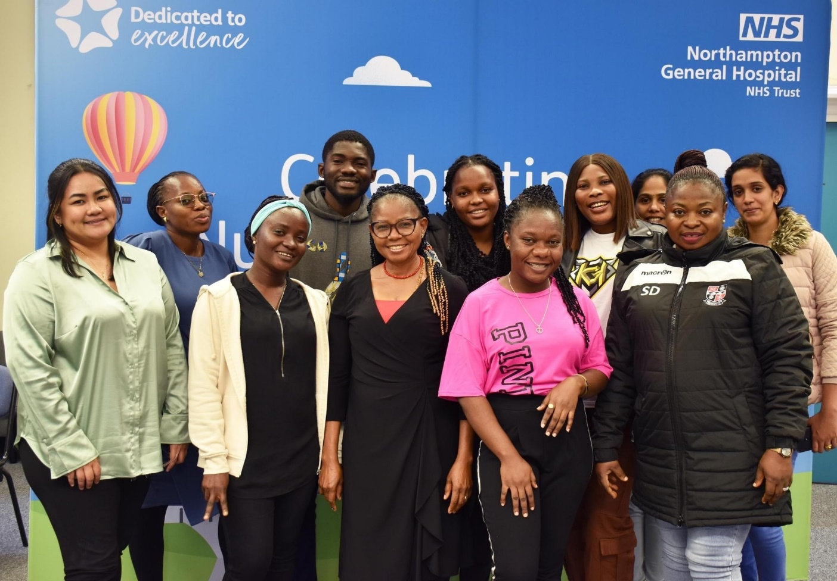Some of our International Nurses in 2022

Workforce Race Equality Standard (WRES)

We undertook the data analysis exercise for the National Workforce Race Equality Standard (WRES) in 2022 and compared these results to those of 2021 to establish if there had been improvements or deteriorations in the experiences or the treatment of BME colleagues when compared to our White colleagues.

We showed improvement in:

- The number of BME colleagues we employee
- The likelihood of BME colleagues accessing non-mandatory training/Continuous Professional Development when compared to White Colleagues
- BME colleagues experiencing bullying, harassment or abuse from other colleagues in the last 12 months
- The percentage difference between our Board voting membership and our overall BME workforce, however despite this improvement our Trust Board does not reflect the overall ethnicity of our workforce.

Deteriorations were seen in:

- The total number of BME colleagues at a very senior manager level
- The likelihood of BME colleagues entering the formal disciplinary process, when compared to White colleagues
- BME colleagues experiencing bullying, harassment or abuse from patients, relatives or the public.
- BME colleagues who have personally experienced discrimination at work from Manager/Team leader

We acknowledge there is still work to do to improve the experiences and treatment of our BME workforce and we will be working closely with our REACH (Race, Ethnicity and Cultural Heritage) Inclusion Network to address the issues highlighted.

Our WRES report can be accessed via our website.

Workforce Disability Equality Standard (WDES)

We undertook the data analysis exercise for the National Workforce Disability Equality Standard (WDES) in 2022 and compared these results to those of 2021 to establish if there had been improvements or deteriorations in the experiences or the treatment of disabled colleagues when compared to our non-disabled colleagues.

We showed improvement in:

- The number of disabled colleagues we employ
- The likelihood of disabled colleagues entering the formal capability process, when compared to non-disabled colleagues
- Disabled colleagues experiencing bullying, harassment or abuse from patients, relatives or the public
- Disabled colleagues believing career progression/promotion is fair when compared to non-disabled colleagues
- Disabled colleagues saying that they have felt pressure from their manager to come to work, despite not feeling well enough to perform their duties
- The percentage difference between our Board voting membership and our overall disabled workforce, however despite this improvement our Trust Board does not reflect the overall workforce.

Deteriorations were seen in:

- The likelihood of disabled applicants being shortlisted when compared to non-disabled applicants
- Disabled colleagues experiencing bullying, harassment or abuse from other colleagues in the last 12 months
- Disabled colleagues experiencing bullying, harassment or abuse from managers in the last 12 months
- Disabled colleagues or their colleagues reporting bullying, harassment or abuse
- Disabled colleagues compared to non-disabled colleagues saying that they are satisfied with the extent to which their organisation values their work.
- Disabled colleagues saying that their employer has made adequate adjustments to enable them to carry out their work
- Colleagues Engagement score for disabled colleagues compared to non-disabled colleagues and the overall engagement score for the organisation.

We acknowledge there is still work to do to improve the experiences and treatment of our disabled workforce and we will be working closely with DAWN (Disability and Wellbeing Network) to address the issues highlighted.

Our WDES report can be accessed via our website.

Gender Pay Gap Reporting

As per the Gender Pay Gap Information Regulations 2017, we compiled and analysed our data and submitted it to the Government, as part of the requirements under the Regulations. Although we are not legally required to produce a written report, it was agreed this should be done to give context to the data and this will be published on our website.

There has been an improvement in the gap since last year. Resulting in female employees earning 91p for every £1 that a male employee earns, instead of 88p.

Mean Hourly Rates, the difference and percentage pay gap, from 2021 to 2022
 | Mean Hourly Rate 2021 | Mean Hourly Rate 2022 | Mean Hourly Rate 2021/22 Variation
Male | £24.95 | £22.95 | -£2.00
Female | £16.96 | £17.83 | +0.87
Difference | £7.99 | £5.12 | -£2.87
Pay Gap | 32.0% | 22.3% | -9.7%

Median Hourly Rates, the difference & percentage pay gap, from 2021 to 2022
 | Median Hourly Rate 2021 | Median Hourly Rate 2022 | Median Hourly Rate 2021/22 Variation
Male | £17.24 | £17.82 | +£0.58
Female | £15.10 | £16.16 | +£1.06
Difference | £2.14 | £1.66 | -£0.48
Pay Gap | 12.5% | 9.3% | -3.2%

We acknowledge there is a difference in the average pay of our male and female colleagues that needs to be addressed, which includes a greater female representation in our senior clinical roles.

Our Gender Pay Gap report can be accessed via our website.

Staff Survey 2022 Equality & Diversity Results

For 2022 Survey People Promise Themes ‘We are Compassionate and Inclusive we scored 6.9 out of 10. We are below the national average of 7.1.

We scored 7.8 for the sub score ‘Diversity and Equality’ and 6.6 for the sub score for ‘Inclusion’.

Underpinning this theme there are 4 questions from the Staff Survey that contribute to the overall ‘theme’ result, in relation to Diversity and Equality:

Question 15 – Does your organisation act fairly with regard to career progression/promotion, regardless of ethnic background, gender, religion, sexual orientation, disability or age? There has been a deterioration of 0.5% since 2021 and we are worse than the national average by 4.4%. The national average has deteriorated by 0.2% since the 2021 survey.

Question 16a – In the last 12 months have you personally experienced discrimination at work from patients/service users, their relatives or other members of the public? There has been a deterioration 0.8% since 2021 and we are worse than the national average by 1.6%. The national average has deteriorated by 0.8% since the 2021 survey.

Question 16b –In the last 12 months have you personally experienced discrimination at work from managers/team leaders or other colleagues? There has been an improvement of 0.6% since 2021 and we are worse than the national average by 3.5%. The national average has improved by 0.1% since the 2021 survey.

Question 20 – I think my organisation respects individual differences (e.g. cultures, working styles, backgrounds, ideas etc.). There has been no change since the 2021 survey and we remained at 63.5%. We are worse than the national average by 5.8%. The national average has improved by 1.7% since the 2021 survey.

The survey has highlighted some areas of concern and we will be working with our colleagues, trades unions and Inclusion Networks to understand the specific issues behind the results so that we can work together to create an inclusive environment where all colleagues are respected and valued.

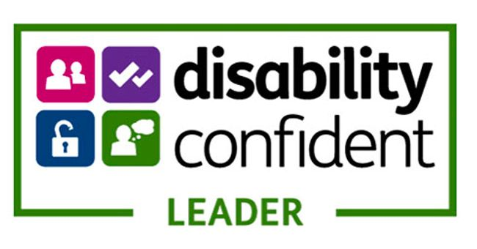

Our Colleagues

The Trust employs 5232.35 whole time equivalent (wte) colleagues, a headcount of 5907 (as at 31 March 2023).

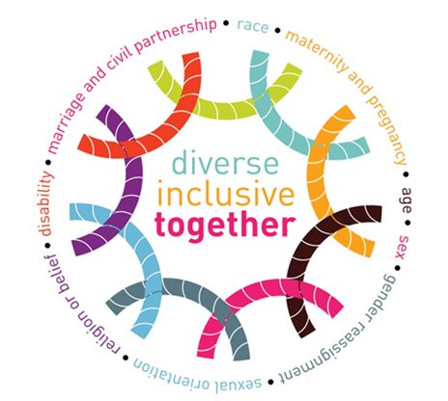
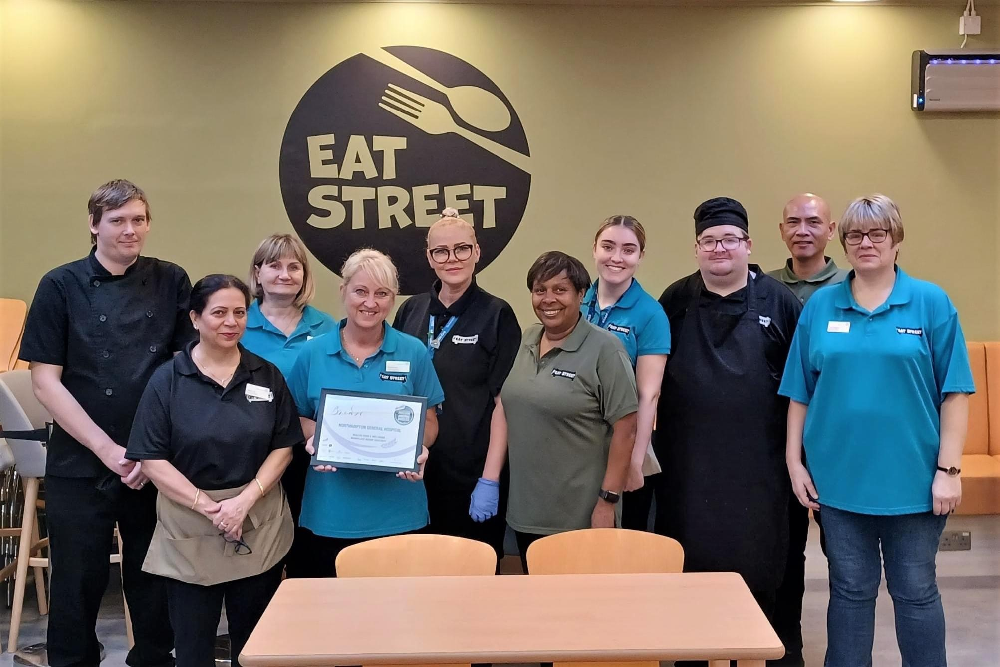
Colleagues from our Catering Team

Age

The overall age profile for the Trust is shown in the chart below:

Age by Pay Band

Band | Age Group | % | All Colleagues %
Bands 4 and Below | Under 20 | 4% | 2%
 | 21-25 | 7% | 6%
 | 26-30 | 10% | 13%
 | 31-35 | 11% | 16%
 | 36-40 | 11% | 12%
 | 41-45 | 10% | 11%
 | 46-50 | 10% | 11%
 | 51-55 | 12% | 11%
 | 56-60 | 14% | 10%
 | Over 61 | 11% | 8%
 | Total | 100%
Bands 5-7 | Under 20 | 0% | 2%
 | 21-25 | 5% | 6%
 | 26-30 | 14% | 13%
 | 31-35 | 21% | 16%
 | 36-40 | 14% | 12%
 | 41-45 | 11% | 11%
 | 46-50 | 12% | 11%
 | 51-55 | 9% | 11%
 | 56-60 | 8% | 10%
 | Over 61 | 6% | 8%
 | Total | 100%
Band 8 and Above including VSM | Under 20 | 0% | 2%
 | 21-25 | 0% | 6%
 | 26-30 | 2% | 13%
 | 31-35 | 10% | 16%
 | 36-40 | 12% | 12%
 | 41-45 | 17% | 11%
 | 46-50 | 18% | 11%
 | 51-55 | 18% | 11%
 | 56-60 | 16% | 10%
 | Over 61 | 7% | 8%
 | Total | 100%
Medical & Dental | Under 20 | 0% | 2%
 | 21-25 | 5% | 6%
 | 26-30 | 20% | 13%
 | 31-35 | 19% | 16%
 | 36-40 | 14% | 12%
 | 41-45 | 11% | 11%
 | 46-50 | 12% | 11%
 | 51-55 | 9% | 11%
 | 56-60 | 6% | 10%
 | Over 61 | 4% | 8%
 | Total | 100%

Age by New Starters and Leavers

Between 1 April 2022 and 31 March 2023 there were 1220 new starters and 625 leavers from the Trust.

Disability

The overall disability profile for the Trust is shown in the chart below:

Disability by Pay Band

Band | Disability | % | All Colleagues %
Bands 4 and Below | No | 83% | 83%
 | Not Declared | 3% | 4%
 | Prefer Not to Answer | 1% | 1%
 | Unspecified | 7% | 7%
 | Yes | 6% | 5%
 | Total | 100%
Bands 5-7 | No | 84% | 83%
 | Not Declared | 5% | 4%
 | Prefer Not to Answer | 1% | 1%
 | Unspecified | 7% | 7%
 | Yes | 3% | 5%
 | Total | 100%
Band 8 and Above including VSM | No | 82% | 83%
 | Not Declared | 4% | 4%
 | Prefer Not to Answer | 1% | 1%
 | Unspecified | 9% | 7%
 | Yes | 4% | 5%
 | Total | 100%
Medical & Dental | No | 83% | 83%
 | Not Declared | 6% | 4%
 | Prefer Not to Answer | 1% | 1%
 | Unspecified | 7% | 7%
 | Yes | 3% | 5%
 | Total | 100%

Disability by New Starters and Leavers

Between 1 April 2022 and 31 March 2023 there were 1220 new starters and 625 leavers at the Trust.

Ethnicity

The overall ethnicity profile for the Trust is shown in the chart below:

Ethnicity by Pay Band

Band | Ethnicity | Total | % | All Colleagues %
Bands 4 and Below | White | 1887 | 78% | 64%
 | Mixed | 51 | 2% | 2%
 | Asian | 218 | 10% | 20%
 | Black | 158 | 7% | 8%
 | Other | 33 | 1% | 3%
 | Not Stated / Specified | 57 | 2% | 3%
 | Total | 2404 | 100%
Bands 5-7 | White | 1436 | 58% | 64%
 | Mixed | 33 | 1% | 2%
 | Asian | 608 | 25% | 20%
 | Black | 230 | 10% | 8%
 | Other | 95 | 4% | 3%
 | Not Stated / Specified | 61 | 2% | 3%
 | Total | 2463 | 100%
Band 8 and Above including VSM | White | 251 | 85% | 64%
 | Mixed | 4 | 1% | 2%
 | Asian | 25 | 8% | 20%
 | Black | 8 | 3% | 8%
 | Other | 5 | 2% | 3%
 | Not Stated / Specified | 3 | 1% | 3%
 | Total | 296 | 100%
Medical & Dental | White | 217 | 29% | 64%
 | Mixed | 36 | 5% | 2%
 | Asian | 358 | 48% | 20%
 | Black | 58 | 8% | 8%
 | Other | 46 | 6% | 3%
 | Not Stated / Specified | 29 | 4% | 3%
 | Total | 744 | 100%

Ethnicity by New Starters and Leavers

Between 1 April 2022 and 31 March 2023 there were 1220 new starters and 625 leavers at the Trust.

Marital Status

The overall marital status profile for the Trust is shown in the chart below:

Marital Status by Pay Band

Band | Marital Status | % | All Colleagues %
Bands 4 and Below | Civil Partnership | 2% | 1%
 | Divorced | 8% | 6%
 | Legally Separated | 1% | 1%
 | Married | 46% | 52%
 | Single | 39% | 34%
 | Unknown | 3% | 5%
 | Widowed | 1% | 1%
 | Total | 100%
Bands 5-7 | Civil Partnership | 1% | 1%
 | Divorced | 5% | 6%
 | Legally Separated | 1% | 1%
 | Married | 54% | 52%
 | Single | 33% | 34%
 | Unknown | 5% | 5%
 | Widowed | 1% | 1%
 | Total | 100%
Band 8 and Above including VSM | Civil Partnership | 1% | 1%
 | Divorced | 6% | 6%
 | Legally Separated | 1% | 1%
 | Married | 68% | 52%
 | Single | 20% | 34%
 | Unknown | 3% | 5%
 | Widowed | 1% | 1%
 | Total | 100%
Medical & Dental | Civil Partnership | 1% | 1%
 | Divorced | 1% | 6%
 | Legally Separated | 1% | 1%
 | Married | 56% | 52%
 | Single | 30% | 34%
 | Unknown | 10% | 5%
 | Widowed | 1% | 1%
 | Total | 100%

Marital Status by New Starters and Leavers

Between 1 April 2022 and 31 March 2023 there were 1220 new starters and 625 leavers at the Trust.

Religious Belief

The overall religious belief profile for the Trust is shown in the chart below:

Religious Belief by Pay Band

Band | Religious Belief | % | All Colleagues %
Bands 4 and Below | Atheism | 15% | 13%
 | Buddhism | 1% | 1%
 | Christianity | 47% | 47%
 | Hinduism | 2% | 5%
 | Not Disclosed | 14% | 13%
 | Islam | 3% | 6%
 | Jainism | 1% | 1%
 | Judaism | 1% | 1%
 | Other | 11% | 8%
 | Sikhism | 1% | 1%
 | Unspecified | 4% | 4%
 | Total | 100%
Bands 5-7 | Atheism | 13% | 13%
 | Buddhism | 1% | 1%
 | Christianity | 56% | 47%
 | Hinduism | 4% | 5%
 | Not Disclosed | 13% | 13%
 | Islam | 1% | 6%
 | Jainism | 0% | 1%
 | Judaism | 1% | 1%
 | Other | 7% | 8%
 | Sikhism | 1% | 1%
 | Unspecified | 3% | 4%
 | Total | 100%
Band 8 and Above including VSM | Atheism | 18% | 13%
 | Buddhism | 1% | 1%
 | Christianity | 49% | 47%
 | Hinduism | 2% | 5%
 | Not Disclosed | 12% | 13%
 | Islam | 2% | 6%
 | Jainism | 1% | 1%
 | Judaism | 1% | 1%
 | Other | 8% | 8%
 | Sikhism | 1% | 1%
 | Unspecified | 5% | 4%
 | Total | 100%
Medical & Dental | Atheism | 8% | 13%
 | Buddhism | 4% | 1%
 | Christianity | 21% | 47%
 | Hinduism | 16% | 5%
 | Not Disclosed | 12% | 13%
 | Islam | 29% | 6%
 | Jainism | 1% | 1%
 | Judaism | 1% | 1%
 | Other | 2% | 8%
 | Sikhism | 1% | 1%
 | Unspecified | 5% | 4%
 | Total | 100%

Religious Belief by New Starters and Leavers

Between 1 April 2022 and 31 March 2023 there were 1220 new starters and 625 leavers at the Trust.

Sex/Gender

The overall sex/gender profile for the Trust is shown in the chart below:

Sex/Gender by Pay Band

Band | Sex/Gender | % | All Colleagues %
Bands 4 and Below | Female | 79% | 78%
 | Male | 21% | 22%
 | Total | 100%
Bands 5-7 | Female | 86% | 78%
 | Male | 14% | 22%
 | Total | 100%
Band 8 and Above including VSM | Female | 77% | 78%
 | Male | 23% | 22%
 | Total | 100%
Medical & Dental | Female | 46% | 78%
 | Male | 54% | 22%
 | Total | 100%

Sex/Gender by New Starters and Leavers

Between 1 April 2022 and 31 March 2023 there were 1220 new starters and 625 leavers at the Trust.

Sexual Orientation

The overall sexual orientation profile for the Trust is shown in the chart below:

Sexual Orientation by Pay Band

Band | Sexual Orientation | % | All Colleagues %
Bands 4 and Below | Bisexual | 2% | 1%
 | Gay or Lesbian | 2% | 1%
 | Heterosexual or Straight | 80% | 82%
 | Not stated | 10% | 10%
 | Other sexual orientation | 1% | 1%
 | Undecided | 1% | 1%
 | Unspecified | 4% | 4%
 | Total | 100%
Bands 5-7 | Bisexual | 1% | 1%
 | Gay or Lesbian | 1% | 1%
 | Heterosexual or Straight | 81% | 82%
 | Not stated | 12% | 10%
 | Other sexual orientation | 1% | 1%
 | Undecided | 1% | 1%
 | Unspecified | 4% | 4%
 | Total | 100%
Band 8 and Above including VSM | Bisexual | 1% | 1%
 | Gay or Lesbian | 1% | 1%
 | Heterosexual or Straight | 84% | 82%
 | Not stated | 8% | 10%
 | Other sexual orientation | 1% | 1%
 | Undecided | 0% | 1%
 | Unspecified | 5% | 4%
 | Total | 100%
Medical & Dental | Bisexual | 1% | 1%
 | Gay or Lesbian | 1% | 1%
 | Heterosexual or Straight | 82% | 82%
 | Not stated | 10% | 10%
 | Other sexual orientation | 1% | 1%
 | Undecided | 0% | 1%
 | Unspecified | 5% | 4%
 | Total | 100%

Sexual Orientation by New Starters and Leavers

Between 1 April 2022 and 31 March 2023 there were 1220 new starters and 625 leavers at the Trust.

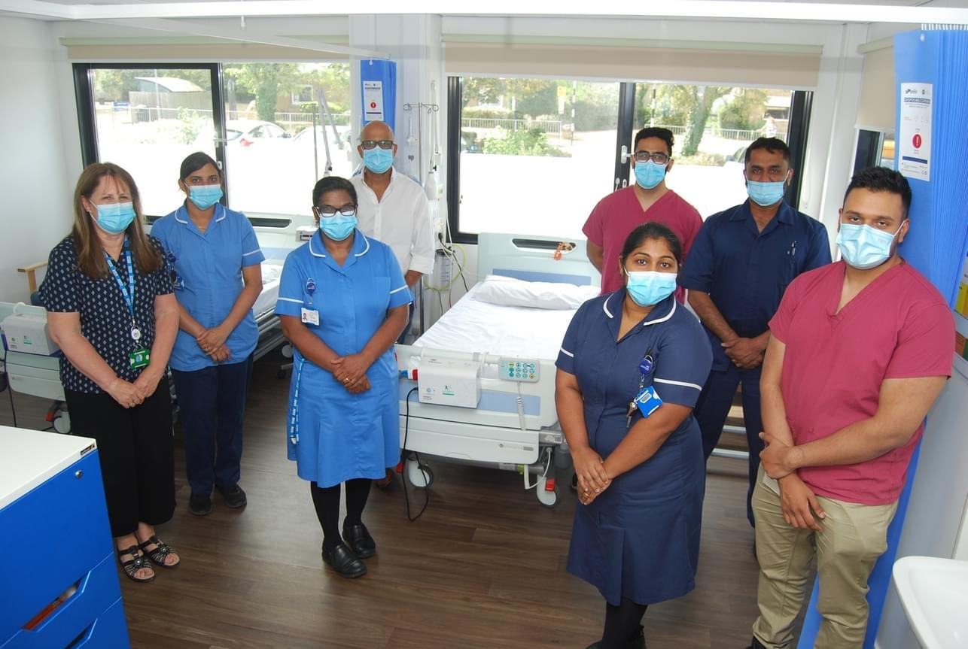

Northampton General Hospital NHS Trust

Our Contact Details are:

- Cliftonville, Northampton, NN1 5BD
- 01604 634700
- www.ngh.nhs.uk
- Find us on Facebook
- Follow us on Twitter @nghnhstrust
- Follow us on Instagram

