Gender Pay Gap Report 2021

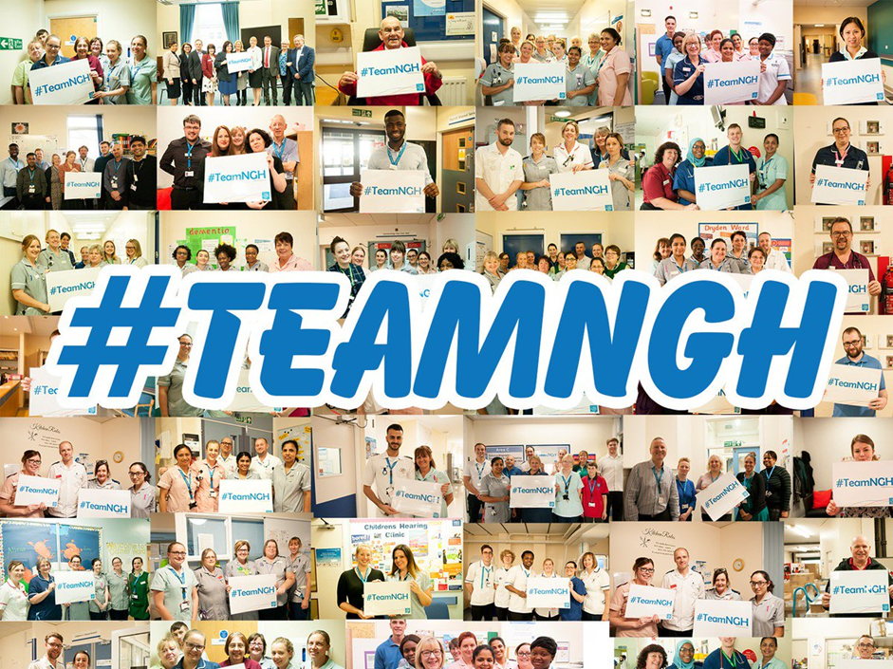

Introduction

In line with the Equality Act 2010 (Gender Pay Gap Information Regulations 2017), Northampton General Hospital NHS Trust has undertaken gender pay gap reporting on the snapshot date of 31 March 2020.

The Trust has calculated the following for its employees and workers:

- The mean gender pay gap
- The median gender pay gap
- The mean bonus gender pay gap
- The median bonus gender pay gap
- The proportion of males receiving a bonus payment
- The proportion of females receiving a bonus payment
- The proportion of males and females in each quartile pay band

At the time the snapshot was taken the Trust had 5969 employees/workers, of which 4731 (79.26%) were female and 1238 (20.74%) were male.

Compared to the 2019 report the workforce has increased by 462 members of staff. The female workforce has increased by 0.09% and the male workforce has decreased by the same percentage.

The ratio of male to female staff that the Trust has is commonplace for an acute district general hospital such as Northampton. The greatest proportion of staff at the Trust are Nurses, Midwives and Healthcare Assistants.

The majority of these staff are female and the number of registrants with the Nursing and Midwifery Council (NMC) supports this. In their Annual Report and Accounts 2019–2020 they reported that, as of 31 March 2020, 89% of the people on their register were women compared to 11% who were men and this proportion has not changed since 2014–2015.

NHS Pay Structure

The majority of staff at the Trust are on the national Agenda for Change Terms and Conditions of Service. The basic pay structure for these staff is across 8 pay bands and staff are assigned to one of these pay bands on the basis of job weight, as measured by the NHS Job Evaluation Scheme. Within each band there are a number of incremental pay progression points as agreed by the NHS National Staff Council.

During 2018 The NHS Staff Council reached agreement on reform of the NHS Terms and Conditions of Service (Agenda for Change), resulting in a three-year pay deal, as well as reform of the pay structure and changes to terms and conditions. As a result, the new pay structure increased starting salaries, reduced the number of pay points in each band and will shorten the amount of time it takes to reach the top of the pay band for most staff.

Medical and Dental staff have different sets of Terms and Conditions of Service, depending on seniority. However, these too are set across a number of pay scales, for basic pay, which have varying numbers of thresholds within them.

There are separate arrangements for Very Senior Managers, such as Chief Executives, Directors and other senior managers who are not on an Agenda for Change Terms and Conditions of Service.

As a public sector organisation, some of the services that are provided are on a 24/7 basis and therefore staff that work unsocial hours, participate in on-call rotas and work on general public holidays will also be in receipt of enhanced pay in addition to their basic pay. This mainly applies to clinical staff who work in ward areas along with non-clinical senior managers, who participate in the Senior Manager/Executive on-call rota and non-clinical staff who provide 24/7 services such as Estates and auxiliary staff.

The Trust does have a number of clinical departments that do not provide 24/7 such as clinics and outpatient areas and therefore these staff roles may not attract enhancements.

Mean Gender Pay Gap

The mean hourly rate is the average hourly wage across the entire organisation so the mean gender pay gap is a measure of the difference between women’s mean hourly wage and men’s mean hourly wage.

The 2020 mean gender pay gap for the Trust demonstrates that female staff are paid 27.9% less than male staff. This is a decrease of 2.2% in the mean pay gap from the previous year, as demonstrated in Table 1 below:

Table 1 - Mean Hourly Rates, the difference and percentage pay gap, from 2019 to 2020
 | Mean Hourly Rate 2019 | Mean Hourly Rate 2020 | Mean Hourly Rate 2019/20 Variation
Male | £23.43 | £22.79 | -£0.64%
Female | £16.37 | £16.42 | +£0.05%
Difference | £7.06 | £6.37 | -£0.69
Pay Gap | 30.1% | 27.9% | -2.2%

Median Gender Pay Gap

The median hourly rate is calculated by ranking all employees from the highest paid to the lowest paid, and taking the hourly wage of the person in the middle, so the median gender pay gap is the difference between women’s median hourly wage (the middle paid woman) and men’s median hourly wage (the middle paid man).

The 2020 median gender pay gap for the Trust demonstrates that female staff are paid 11.5% less than male staff. This is a decrease of 1.8% in the median pay gap from the previous year, as demonstrated in Table 2 below:

Table 2 - Median Hourly Rates, the difference and percentage pay gap, from 2019 to 2020
 | Median Hourly Rate 2019 | Median Hourly Rate 2020 | Median Hourly Rate 2019/20 Variation
Male | £16.66 | £16.23 | -£0.43
Female | £14.44 | £14.37 | -£0.07
Difference | £2.22 | £1.86 | -£0.36
Pay Gap | 13.3% | 11.5% | -1.8%

Mean Bonus Gender Pay Gap

This calculation includes the bonuses that were paid to workers on the Clinical Nurse Bank who completed 150 hours of bank work. This is part of the Trust’s bonus loyalty scheme to increase the numbers of clinical bank workers and reduce the use of agency staff. Recipients of these bonuses are primarily Nurses, Midwives and Healthcare Assistants. It also includes any Clinical Excellence Awards (CEA’s) awarded to Consultants.

The 2020 mean bonus gender pay gap for the Trust demonstrates that female staff are paid 80.3% less than male staff. This is a decrease of 1.8% in the mean bonus gender pay gap from the previous year, as demonstrated in Table 3 below:

Table 3 - Mean Bonus Rates, the difference and percentage pay gap, from 2019 to 2020
 | Mean Bonus Rate 2019 | Mean Bonus Rate 2020 | Mean Bonus Rate 2019/20 Variation
Male | £6,610.44 | £5,889.09 | -£721.35
Female | £1,185.78 | £1,159.92 | -£25.86
Difference | £5,424.66 | £4,729.17 | -695.49
Pay Gap | 82.1% | 80.3% | -1.8%

Median Bonus Gender Pay Gap

The 2020 median bonus gender pay gap for the Trust demonstrates that female staff are paid 78.3% less than male staff. This is a decrease of 1.8% in the median bonus gender pay gap from the previous year, as demonstrated in Table 4 below:

Table 4 - Median Bonus Rates, the difference and percentage pay gap, from 2019 to 2020
 | Median Bonus Rate 2019 | Median Bonus Rate 2020 | Median Bonus Rate 2019/20 Variation
Male | £3,015.96 | £2764.63 | -£251.33
Female | £600 | £600 | £0
Difference | £2,415.96 | £2,164.63 | -£251.33
Pay Gap | 80.1% | 78.3% | -1.8%

Proportion of Males and Females Receiving a Bonus Payment

Of the total workforce eligible for bonuses (Consultants in receipt of CEA payments and those registered as workers on the Clinical Nurse Bank), 9.7% of males received bonuses compared to 16.4% of females. This is a decrease of 2.3% and 0.3% respectively, as demonstrated in Table 5 below:

Table 5 – Proportion of Males and Females Receiving a Bonus Payment from 2019 to 2020
 | Bonus Rate 2019 | Bonus Rate 2020 | Bonus Rate 201/20 Variation
Male | 12% | 9.7% | -2.3%
Female | 16.7% | 16.4% | -0.3%
Difference | 4.7% | 6.7% | +2%

Proportion of Males and Females in Each Quartile Pay Band

At the time the snapshot was taken the percentage of female staff was 79.26% and the percentage of male staff was 20.74%.

As shown in Table 6, below, the percentage of females in the all the quartiles is greater than the male percentage. In the lower and lower middle quartiles the split is broadly representative of the Trust split. In the upper middle quartile the number of females reduces and in the upper quartile there is a significant reduction of in females compared to males.

Table 6 – Proportion of Males and Females in Each Quartile Pay Band from 2019 to 2020
Quartile | 2019 |  |  | 2020
 | Gender | Number | % | Gender | Number | %
Lower | Male | 273 | 19.8% | Male | 285 | 19.1%
 | Female | 1103 | 80.2% | Female | 1207 | 80.9%
Lower Middle | Male | 235 | 17.1% | Male | 271 | 18.2%
 | Female | 1142 | 82.9% | Female | 1221 | 81.8%
Upper Middle | Male | 200 | 14.5% | Male | 222 | 14.9%
 | Female | 1177 | 85.5% | Female | 1270 | 85.1%
Upper | Male | 439 | 31.9% | Male | 460 | 30.8%
 | Female | 938 | 68.1% | Female | 1033 | 69.2%

Further Analysis

In relation to the mean and median gender pay gaps further analysis shows that the greatest impact on the gap falls within Consultant workforce as shown below in Table 7 and 8 and has a greater number of male staff than female staff within them.

Other Medical and Dental Staff also have a significant gender pay gap and for the mean calculation. However, the median calculation is +0.7%.

Agenda for Change Bands 8a-9 is -0.3% for the mean calculation and -3.6% for the median.

For both the mean and the median calculation Agenda for Change Bands 1-7 show that our female staff are paid more than our male staff at +7.2% and +11.8% respectively.

Our female Very Senior Managers are at + 9% for the mean calculation and -2.7% for the median calculation.

Table 7 – Split of Mean Gender Pay Gap by Staff Groups

 | Consultants |  | Other Medical & Dental |  | Agenda for Change Bands 8a – 9 |  | Agenda for Change Bands  1-7 |  | Very Senior Managers
Male | £59.31  (166) | -11.8% | £24.46  (199) | -6.7% | £27.61  (54) | -0.3% | £13.74  (756) | +7.2% | £61.14  (7) | +9%
Female | £52.30  (84) |  | £22.81  (187) |  | £27.52  (156) |  | £14.72  (4291) |  | £66.64  (13)
(Number of staff in staff group)

Table 8 – Split of Median Gender Pay Gap by Staff Groups
 | Consultants |  | Agenda for Change Bands 8a – 9 |  | Very Senior Managers |  | Other Medical & Dental |  | Agenda for  Change Bands  1-7
Male | £56.99  (166) | -10.1% | £26.92  (54) | -3.6% | £53.12  (7) | -2.7% | 26.59  (199) | +0.7% | £12.01  (756) | +11.8%
Female | £51.23  (84) |  | £25.94  (156) |  | £51.66  (13) |  | 26.78  (187) |  | £13.43  (4291)
(Number of staff in staff group)

The graph below further demonstrates that the gap between the numbers of female staff to male staff starts to lessen from the hourly rate of £30 per hour and above and at £50 per hour and above the number of males becomes greater than the number of females.

In respect of the proportion of males and females receiving a bonus payment, our data shows that of the 896 staff who received a bonus, 87 of those were Consultants receiving a Clinical Excellence Award (CEA). Of these 87 Consultants, 65 were male (75%) and 22 were female (25%). The average CEA payment calculation was £10,018 for males compared to £9,003 for females, resulting in a gap in bonus pay of £1,015 for Clinical Excellence Awards.

Conclusion

The Trust continues to be committed to taking action in order to close the gender pay issues identified in this report and it is positive that we have seen some overall improvements compared to last year with our pay gap.

There has been a 2.2% reduction in mean and a 1.8% reduction in median average pay gaps. This suggests that the pay gap can be partially attributed to length of service and, as female staff move through their pay bands, they are catching up to male colleagues who are already higher on the pay scale due to their NHS or equivalent length of service.

The CEA process can be seen as directly linked to length of service in that the longer a consultant has been in post, the more opportunity he or she will have had to apply for the annual CEA awards. There is an opportunity to deep dive into the CEA data. The intended outcome is to co-produce some actions to improve the number of female consultants being awarded a CEA award. In 2020 65 of the 87 Clinical Excellence Awards were awarded to males.

We are committed to the following actions to help to close the gender pay gap

- Explore setting up a women’s network and/or listening events across the Trust to identify key actions to support female staff move into leadership roles

- Review the Trust’s Agile Working policy to ensure this adequately supports all staff

- Review internal recruitment processes to ensure that a fair and consistent approach is taken to enable career progression opportunities for all staff

- Collaborate with the Deanery to explore making the consultant training more flexible and female friendly.

