**Workforce Disability Equality Standard (WDES) Data**

**Percentage of staff members at NGH who are disabled, non-disabled or have not stated their disability status**

*Total Workforce = 5973*

*Disabled = 276*

*Non-Disabled = 4842*

*Not stated = 855*

**AFC Bands**

**Medical & Dental**

**Disabled Non-Disabled Not Stated**

1-4 **4.99%** **82.37% 12.64%**

5-7 **4.74%** **81.51%** **13.75%**

8A-8D **17.65%** **78.15% 4.20%**

9-VSM **0%** **95%** **5%**

**Disabled Non-Disabled Not Stated** Consultants **1.57%** **66.54%** **31.89%**

Sen. Medical Manager **0%**  **100%** **0%**

Career Grade **22.22%** **63.89%** **36.11%**

Trainee Grades **3.19%** **82.61%** **14.2%**

20/21

**Percentage of staff who believe that their organisation provides equal opportunities for career progression or promotion**

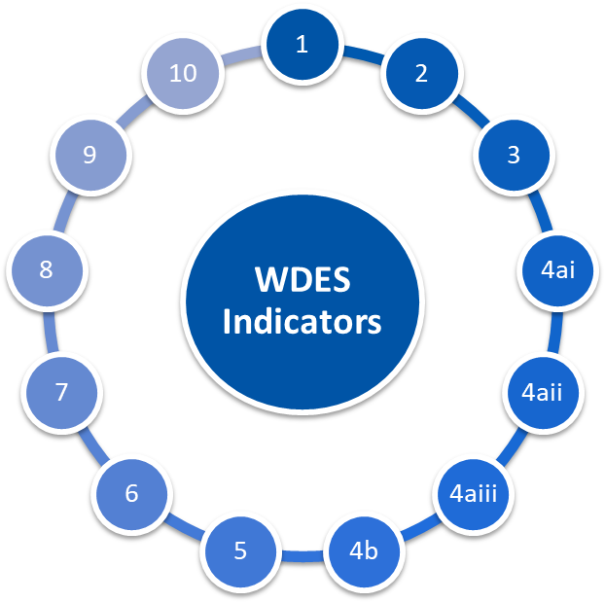

**1.12**

**Disabled 77% Non Disabled 84%**

**Disabled -5% Non Disabled -17%**

**Percentage difference between the organisations’ Board voting membership and its overall workforce**

**Relative likelihood of non-disabled staff compared to Disabled staff being appointed from shortlisting across all posts**

**Engagement score for disabled staff compared to non-disabled and overall engagement score out of 10**

**Disabled 6.7 Non Disabled 7.2 Overall 7**

**o**

**Relative likelihood of Disabled staff entering the formal capability process compared to non-disabled staff**

**5.85**

**79%**

**Percentage of staff with a long lasting health condition or illness saying their employer has made adequate adjustment(s) to enable them to carry out their work**

**Disabled 35%**

**Non Disabled 27%**

**Percentage of staff experiencing harassment, bullying or abuse from patients, relatives or the public in last 12 months**

**Disabled 21%**

**Non Disabled 13%**

**Percentage of staff experiencing harassment, bullying or abuse from manager in last 12 months**

**Disabled 36% Non Disabled 49%**

**Percentage of staff satisfied with the extent to which their organisation values their work**

**Disabled 35% Non Disabled 22%**

**Percentage of staff who have felt pressure from their manager to come to work, despite not feeling well enough to perform their duties**

**Disabled 31% Non Disabled 21%**

**Percentage of staff experiencing harassment, bullying or abuse from other colleagues in last 12 months**

**Percentage of staff saying that the last time they experienced harassment, bullying or abuse at work, they or a colleague reported it**

**Disabled 50% Non Disabled 44%**

**Workforce Disability Equality Standard (WDES) Data**

21/22

**Specific Board Actions:**

**What are we doing / plan to do within the hospital:**

To implement the Inclusive Recruitment Champion process to help eliminate any bias during recruitment and selection process. The aim is to increase diversity at all levels within the Trust for disabled staff and all other protected groups. Phased approach – Interviews for Band 7 and above. Medical & Dental interviews are being reviewed.

Continue the Reverse Mentoring Programme and expand participants to other protected groups (disabled) post-REACH cohort, Board Members to invite their mentor to Board to expand learning for all Board Members.

Disabled staff and staff from other protected groups to attend Board and share their lived experiences within the organisation, utilise Exec Sponsors of DAWN to provide these opportunities and remain a champion at Exec level.

Continue to promote Health & Wellbeing offerings at a national and local level. Continue to share best practice at system meetings to feed back to DAWN and wider organisation.

To implement the RCN Cultural Ambassador programme to support disabled staff during formal and informal HR process to ensure a space/ atmosphere of safety, transparency and support that is offered to the staff.

1

1

Commitment to a Board Development Session to continue to focus on Diversity & Inclusion. To include cultural change training programmes such as Building Cultural Bridges.

Commitment to 6 monthly Inclusion update on EDI progress. Expand focus to disabled staff.

Inclusion of a protected group role model staff story at Board meetings so viewers in those groups can relate.

Focus considerable energy into the relaunched DAWN (Disability & Wellbeing Network) to foster a culture of openness, understanding and action amongst disability issues including mental health and general wellbeing of staff.

2

3

4

5

6

5

4

3

2

Expansion of Executive Sponsorship to include Non-Exec Directors as Sponsors for all Networks and continue to retain the engagement of the Exec Sponsors for the Networks.

Continually champion and foster cultural change within the Trust via specific training programmes with OD team and other measured approached. Work with HRBP’s to triangulate DATIX’s involving disabled staff and hotspot areas of concern.

Take supportive action to increase the diversity of the Board across the Group.

6

Commitment to 6 monthly Inclusion update on EDI progress. Expand focus to disabled staff.