**Workforce Race Equality Standard (WRES) Data**

20/21

**Percentage of staff members at NGH who are White, BME or have not stated their ethnicity.**

*Total Workforce = 5973*

*White = 4159*

*BME = 1657*

*Not stated = 157*

**AFC Bands**

**Medical & Dental**

**White BME Not Stated**

Bands 1-4 **81.37%** **18.63%**  **1.79%**

Bands 5-7 **64.77%** **35.23%**  **2.55%**

Bands 8A-VSM **85.66%** **14.34%** **1.55%**

**White BME Not Stated**

Consultants 48.43**%** **47.64%** **3.94%**

Senior Medical Manager **100%**  **0%** **0%**

Non-Consultant Career Grade **22.22%** **72.22%** **5.56%**

Trainee Grades **26.38%** **64.64%** **8.99%**

**Relative likelihood of BME staff entering the formal disciplinary process compared to White staff**

**Percentage of staff experiencing harassment, bullying or abuse from other colleagues in the last 12 months**

**Percentage of staff experiencing harassment, bullying or abuse from patients, relatives or the public in the last 12 months**

**Relative likelihood of White staff accessing non-mandatory training and CPD compared to BME staff**

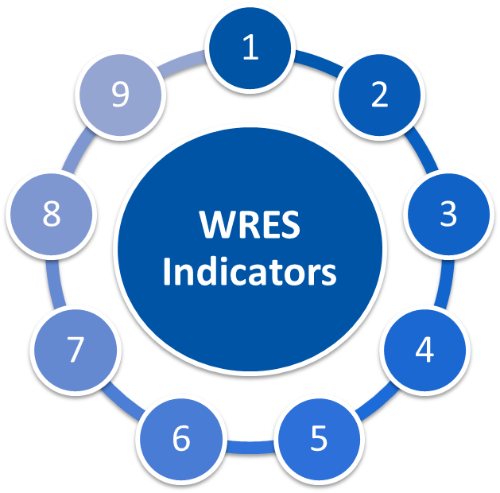

**1.80**

**Deterioration of 0.79 since 2020**

**1.52**

**Deterioration of 0.22 since 2020**

**0.93**

**An improvement of 0.13 in comparison to 2019/20**

**BME -21.5%**

**White 24.1%**

**An improvement of 2.9% from the previous year**

**BME 22%**

**White 7%**

**1% deterioration for BME staff and 1% improvement for White staff**

**BME 64%**

**White 87%**

**4% improvement for BME staff**

**BME 34%**

**White 29%**

**4% improvement for BME staff**

**BME 30%**

**White 28%**

**6% improvement for BME staff**

**Percentage difference between the organisations’ Board voting membership and its overall workforce**

**Percentage of staff who have personally experienced discrimination at work from Manager/Team leader**

**Percentage of staff believing the hospital provides equal opportunities for career progression or promotion**

**Relative likelihood of White staff being appointed from shortlisting compared to BME staff**

21/22

**Workforce Race Equality Standard (WRES) Data**

**Specific Board Actions:**

**What are we doing / plan to do within the hospital:**

Continue the Reverse Mentoring Programme and expand participants to other protected groups whilst retaining a significant percentage of REACH staff, Board Members to invite their mentor to Board to expand learning for all Board Members.

To implement the Inclusive Recruitment Champion process to help eliminate any bias during recruitment and selection process. The aim is to increase diversity at all levels within the Trust for REACH staff and all other protected groups. Phased approach – Interviews for Band 7 and above. Medical & Dental interviews are being reviewed.

1

1

Take supportive action to increase the diversity of the Board across the Group.

Commitment to a Board Development Session to continue to focus on Diversity & Inclusion. To include cultural change training programmes such as Building Cultural Bridges.

Expansion of Executive Sponsorship to include Non-Exec Directors as Sponsors for all Networks and continue to retain the engagement of the Exec Sponsors for the Networks.

Inclusion of a protected group role model staff story at Board meetings so viewers in those groups can relate.

Commitment to 6 monthly Inclusion update on EDI progress with rolling protected groups focus.

6

Continue to promote training programmes at a national, regional, system and local level. Incorporating in-house programmes (Unconscious Bias, Courageous Conversations, KGH Building Cultural Bridges) to embed cultural change within organisation whilst creating a safe space for protected groups

Promote REACH Network Drop In Service to create a safe space for Network members to share feedback on activities or raise cultural issues/concerns to a respective Co-Chair of the Network in confidence. Provide support to those members who need it.

Continually champion and foster cultural change within the Trust via specific training programmes with OD team and other measured approached. Work with HRBP’s to triangulate DATIX’s involving REACH staff and hotspot areas of concern.

Campaign is currently in planning stages to recruit more FTSU Values Ambassadors, beginning with REACH members. This will involve work with Comms to promote the value of FTSU and the positive cultural changes that can occur when staff feel safe to speak up. Increasing visibility for Values Ambassadors to be a champion of FTSU in their respective areas of work.

To implement the RCN Cultural Ambassador programme to support REACH staff during formal and informal HR process to ensure a space/ atmosphere of safety, transparency and support that is offered to the staff.

2

3

4

5

6

5

4

3

2