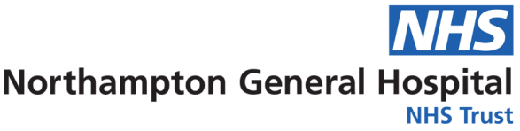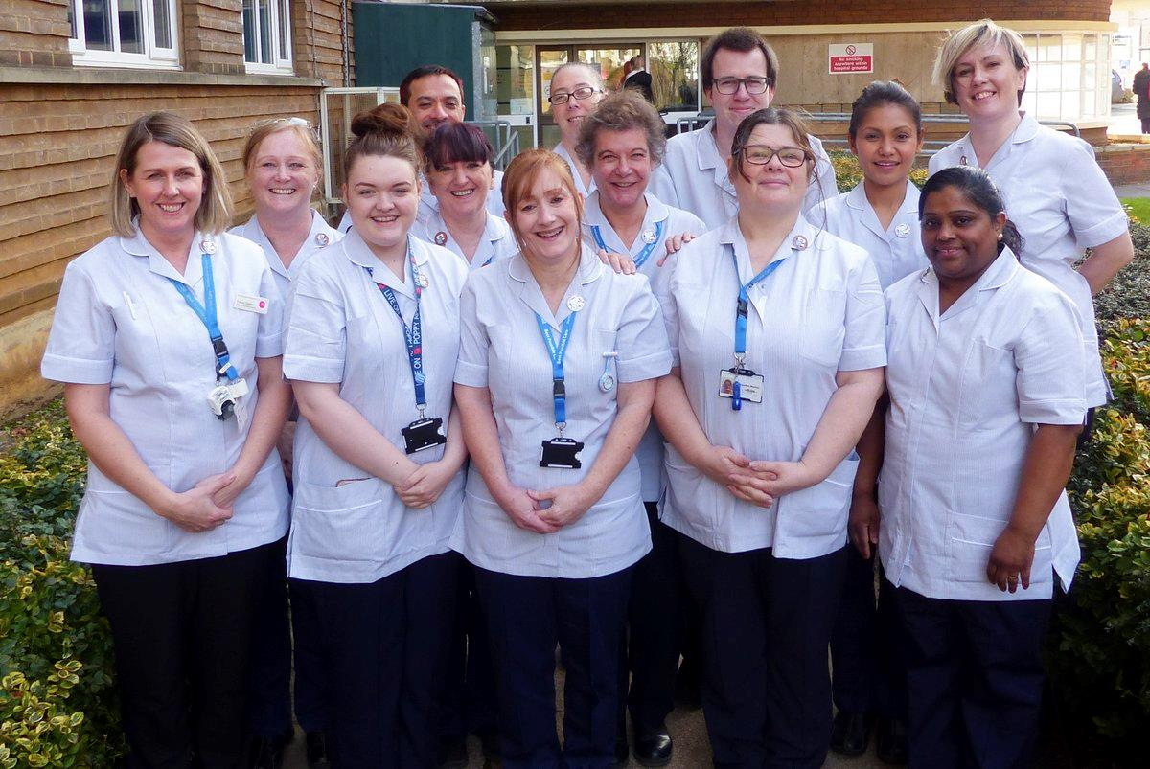

Equality, Diversity & Inclusion

Workforce Annual Report

April 2019 to March 2020

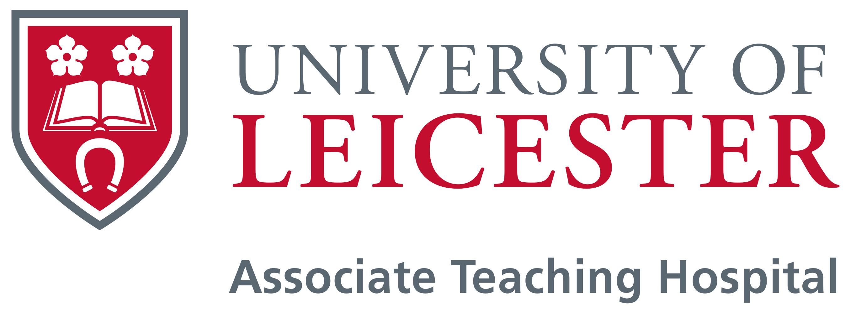

**Equality and Diversity**

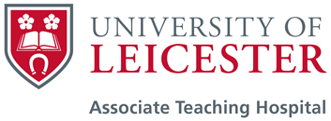

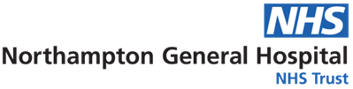

Equality, Diversity and Inclusion

Workforce Annual Report

April 2019 to March 2020

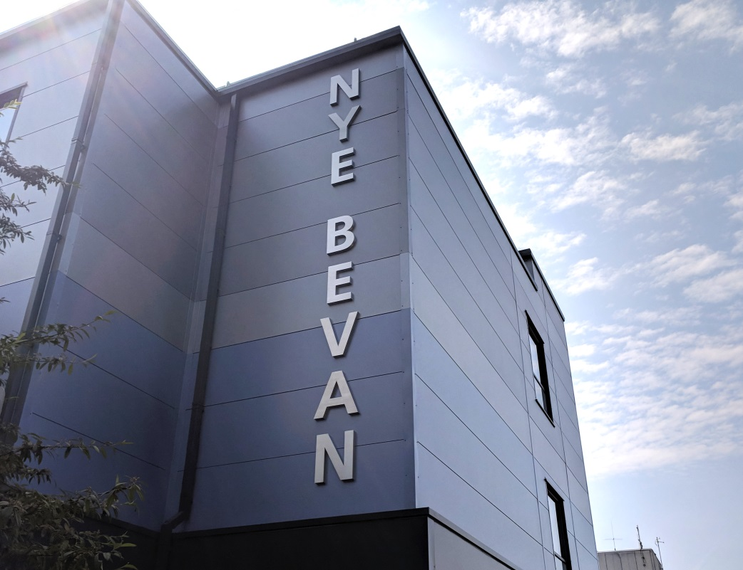

Our Vision and Values

*Our Vision is:* To provide the best possible care for our patients

*Our Values are:*

* We put patient safety above all else
* We aspire to excellence
* We reflect, we learn, we improve
* We respect & support each other



Contents

Executive Summary 6

Introduction 7

Our Population 9

Our People 12

Our Activities 16

Our Workforce Data 30

Executive Summary

The Equality, Diversity and Inclusion Workforce Annual Report for 2019/2020 reviews the work Northampton General Hospital (NGH) has undertaken to promote equality, celebrate diversity create an inclusive workforce during April 2019 to March 2020.

During this time we have started to develop the NGH People Plan, which is focussed on 4 areas - CARE (Culture, Achievement, Resourcing, Environment) to enable us to deliver the best possible care.

The area of ‘culture’ will have key links to diversity and inclusion together with respect and support, civility saves lives, freedom to speak up, leadership behaviour and how we welcome and include employees who are joining the organisation. We look forward to embedding these plans during the coming year.

In the summer of 2019 we launched our Black, Asian and Minority Ethnic (BAME) Staff Group and the NHS Rainbow Badge initiative. Work also took place during early 2020 to set up an LGBT Staff Network Group and a Disability Network Group led by our newly appointed Head of Equality, Diversity & Inclusion.

Following the outbreak of COVID-19 in 2020 the focus of the work of the Trust changed dramatically and many of our normal day to day activities were paused to deal with the pandemic. Throughout this time we remained conscious of the need to continue to be a diverse and inclusive employer to support our staff through this challenging time.

During 2020/2021 we look forward to finalising the NGH People Plan and creating a great place to work, learn and CARE for the people of Team NGH.



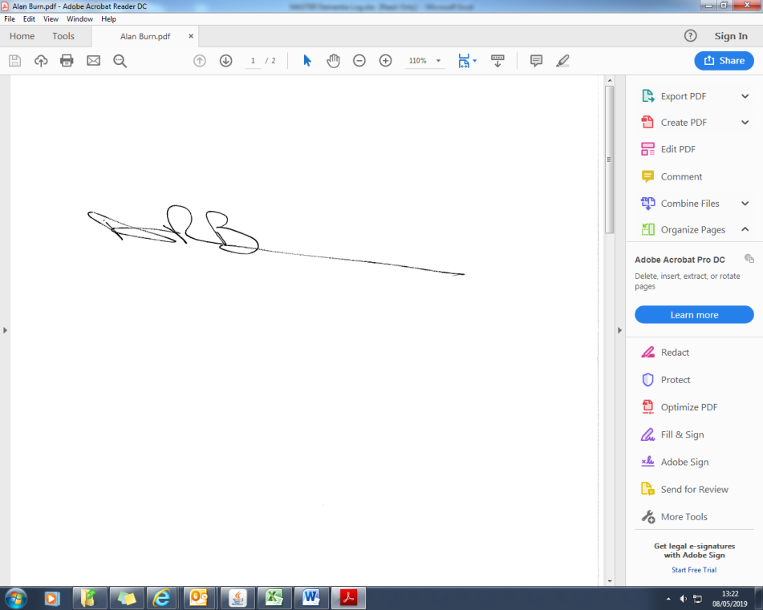

Dr Sonia Swart Alan Burns

*Chief Executive* *Chairman*

**Introduction**

We believe that Equality, Diversity & Inclusion is central to what we do.  We understand the importance of creating a fairer society where everyone has the opportunity to fulfil their potential, whilst recognising and valuing difference and ensuring everyone feels valued and included.

We aim to support our staff in a responsive and appropriate way to meet the diverse needs of the different groups and individuals we employ, because well supported staff can deliver better care for our patients.

To achieve this we want to ensure that our staff are not subject to any form of discrimination or unequal treatment. All staff can expect to be treated with equal respect and dignity regardless of their background or circumstances. Dignity and respect are at the foundation of the work we do at the Trust, supported by our value of ‘We Respect and Support Each Other’.

It is important to us that we eliminate discrimination in the way we recruit, train and support our workforce and advance equality of opportunity.

Further information regarding Equality, Diversity and Inclusion can be found on our website at

<https://www.northamptongeneral.nhs.uk/About/Equality-and-diversity-information/Equality-Diversity-Inclusion.aspx>

A summary of some of our achievements during 2019/2020 can be found on the next page.

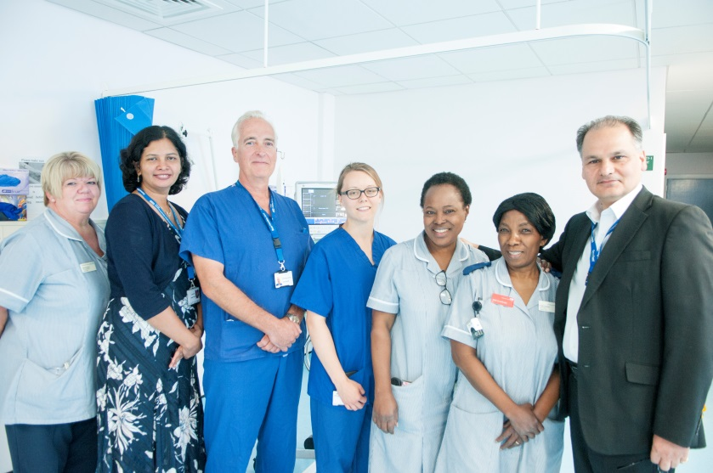

**2019/2020 Summary**

**Head of Equality, Diversity & Inclusion**

We appointed a dedicated member of staff to work with staff and patients

**Rainbow Badges**

We signed up to the NHS Rainbow Badge initiative.

Over 1,000 staff have now signed up and made a pledge

**Staff Network Groups**

Work has started to set up a Disability and a LGBT+ Staff Network Group

**Staff Network Groups**

We held our first Black, Asian and Minority Ethnic Staff Group

**Workforce Race Equality Standard (WRES)**

Data collection undertaken and analysed to enable action planning on areas for improvement

**Workforce Disability Equality Standard (WDES)**

First data collection undertaken and analysed

**Faith & Belief**

Managers supported to enable them to better understand staff needs in relation to their religion or beliefs

**Health & Wellbeing**

Activities continued to support staff to look after their own health and wellbeing

**Our Population**

Northampton General Hospital NHS Trust provides general acute services for a population of 380,000 and hyper-acute stroke, vascular and renal services to people living throughout whole of Northamptonshire, a population of 692,000.  The Trust is also an accredited cancer centre and provides cancer services to a wider population of 880,000 who live in Northamptonshire and parts of Buckinghamshire.

The principal activity of the Trust is the provision of free healthcare to eligible patients.  We are a hospital that provides the full range of outpatients, diagnostics, inpatient and day case elective and emergency care and also a growing range of specialist treatments that distinguishes our services from many district general hospitals.  We also provide a very small amount of healthcare to private patients.

**Northampton Population (2011 Census)**

|  |  |  |  |  |
| --- | --- | --- | --- | --- |
| **Age Group** | **Ethnic Group** | **Marital Status** | **Religion** | **Sex** |
| 0-17  22.8% | White  84.5% | Single  37.2% | Christian 56.6% | Male  49.5% |
| 18-24  9.9% | Mixed  3.2% | Married  43.5% | Buddhist  0.4% | Female  50.5% |
| 25-29  8.0% | Asian  6.5% | Civil Partnership 0.2% | Hindu  1.6% |  |
| 30-44  22.2% | Black  5.1% | Separated  3.5% | Jewish  0.1% |  |
| 45-59  18.4% | Other  0.7% | Divorced  9.5% | Muslim  4.2% |  |
| 60-64  5.5% |  | Widowed  6.1% | Sikh  0.5% |  |
| 65-74  7.0% |  |  | Other  0.5% |  |
| 75-84  4.4% |  |  | No religion 29.4% |  |
| 85+  1.9% |  |  | Not stated 6.7% |  |

Our People

The Trust employs 4801.35 whole time equivalent (wte) members of staff, a headcount of 5457 people, (as at 31 March 2020).

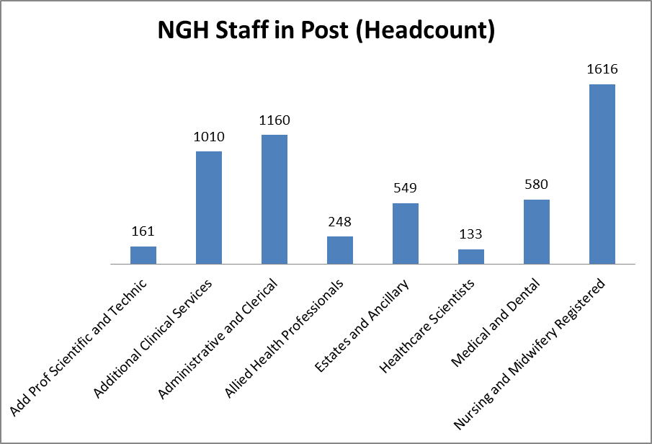

The breakdown of our staff can is detailed on the graphs below by the protected characteristics that data is recorded for.

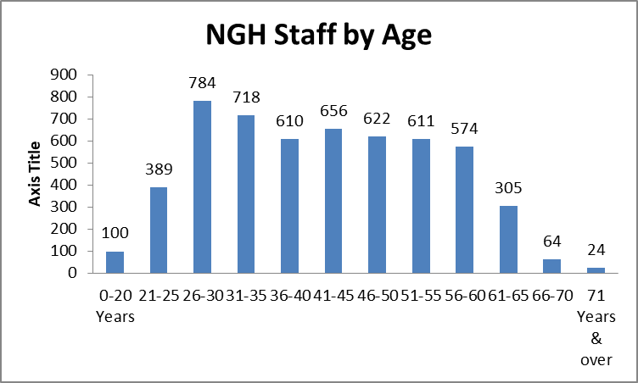

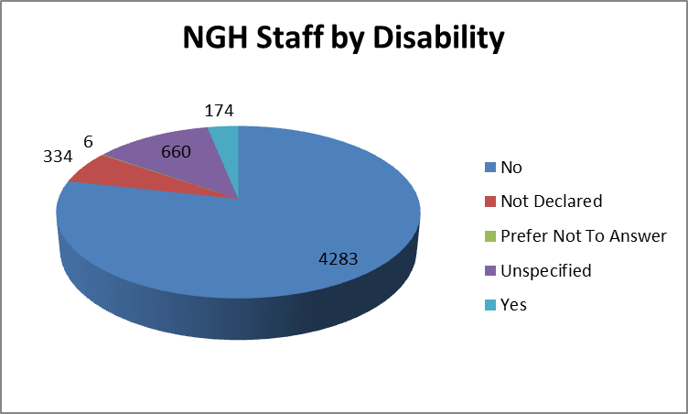

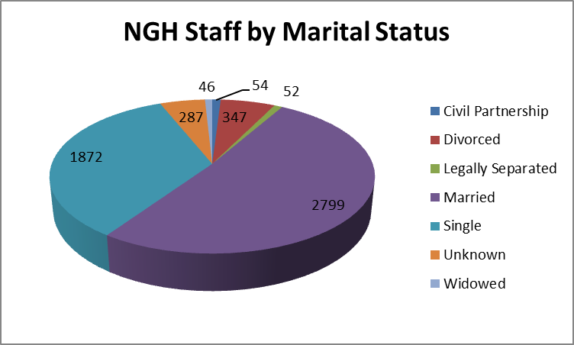

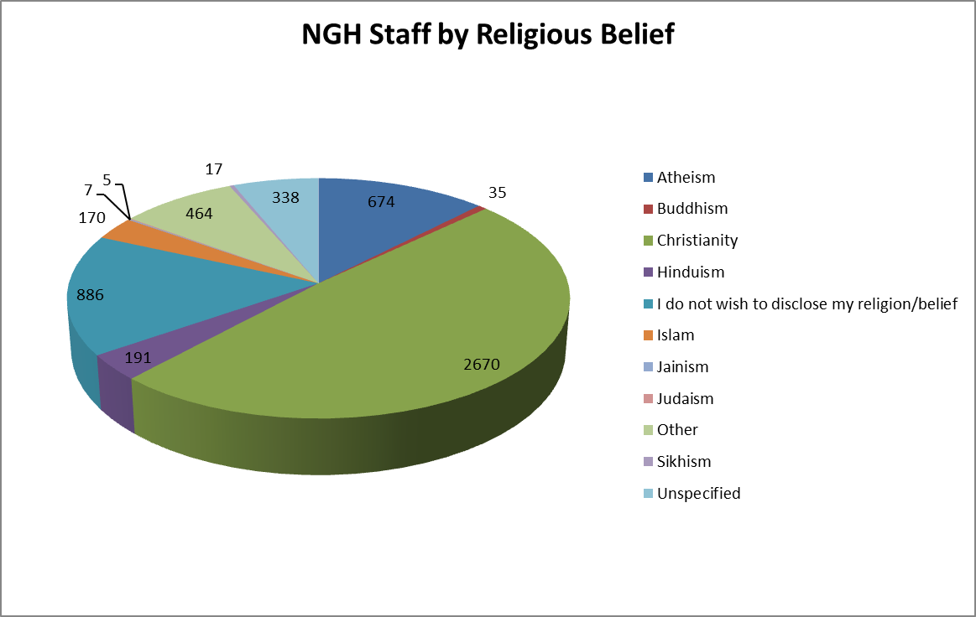

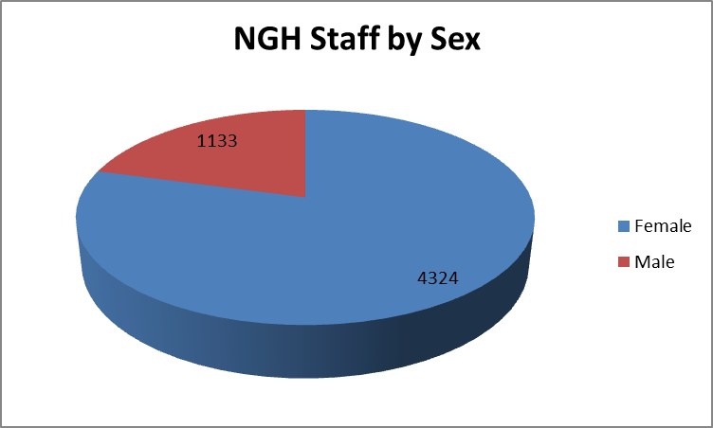

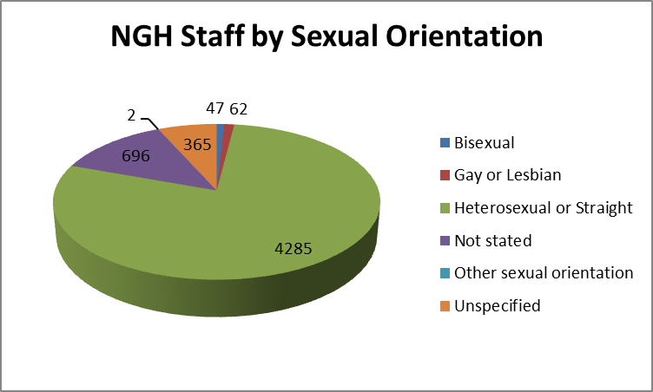

Our Activities

Rainbow Badges

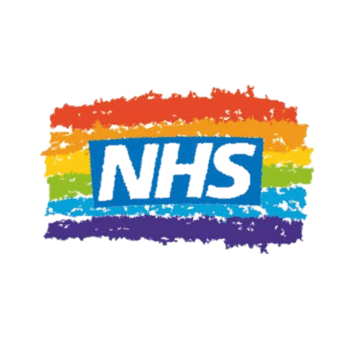

In 2019 we signed up to the NHS Rainbow Badge initiative, with the badges being officially launched at NGH in July 2019.

The Rainbow Badge initiative gives our staff a way to show that we and our organisation is open, non-judgemental and inclusive for patients, their families and our staff, who identify as LGBT+ (lesbian, gay, bisexual, transgender, the + simply means that we are inclusive of all identities, regardless of how people define themselves.)

By choosing to wear the Badge, staff are sending a message that “you can talk to me”. They aren’t expected to have the answers to all issues and concerns but they are a friendly ear, and will know how to signpost to the support available. Staff who chose to wear a badge don’t have to identify as LGBT+ they just have to be willing to listen.

Simple visible symbols, such as the Rainbow Badge, can make a big difference for those unsure of both themselves, and of the reception they will receive if they disclose their sexuality and/or gender identity.

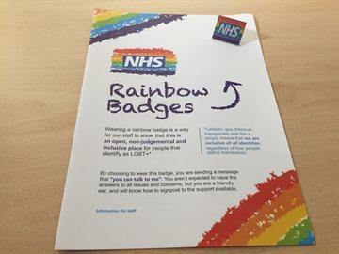

Evidence shows that patients and staff are often discriminated against due to their sexuality (Stonewall):

1. One in 7 (14%) LGBT people avoid seeking healthcare for fear of discrimination
2. Almost one in four (23%) have witnessed discriminatory or negative remarks against LGBT people by healthcare staff
3. Nearly 1 in 5 (18%) LGBT people are not open with work colleagues about sexual orientation
4. Almost one in 5 (18%) have been target of negative comments or behaviour by colleagues due to their sexuality
5. Almost a quarter of NHS staff have heard colleagues making negative remarks about LGBT people.

Since launching the badge over 1,000 staff have signed up and made a pledge to be a listening ear to those that need it.

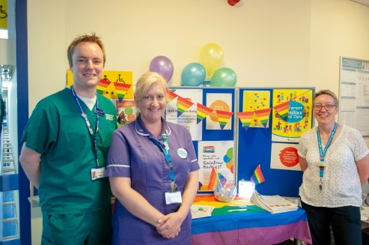

Staff Network Groups

In the summer of 2019 we held our first meeting of our Black, Asian & Minority Ethnic (BAME) Staff Group.

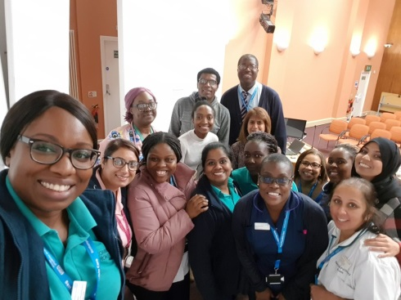

This was followed in early 2020 with work to set up a disability staff network group and a LGBT+ (lesbian, gay, bisexual, transgender +) group as well.

The overall aims of our staff network groups is to:

* To promote positive working experiences for staff
* Provide a safe platform to express views
* To feedback to the Trust on issues that affect those staff
* To feedback on strategic issues and initiatives
* To promote access to opportunities for training and development for staff.

NHS Equality, Diversity & Human Rights Week – 13 to 17 May 2019

The 13 – 17 May 2019 was the eighth NHS Equality, Diversity and Human Rights Week (#EQW2019).

Co-ordinated by NHS Employers, #EQW2019 is a national platform to highlight creating a fairer and more inclusive NHS for patients and staff.

The theme was once again **diverse, inclusive, together** to continue to reflect the move across the health and social care sector towards collaboration and integration. Working together makes the NHS stronger, we meet standards, enable change and collectively invest in the creation of a diverse and inclusive NHS workforce to deliver a more inclusive service and improved patient care.

We asked our staff to think about what they do on a day to day basis to make the Trust to be a diverse, inclusive and together organisation.

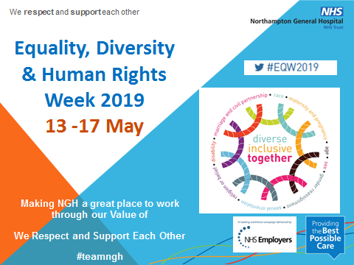

Support for Staff becoming a Parent

During 2019/2020 we continued to provide support for staff becoming a parent to ensure that they are aware of their rights and entitlements. In addition to our Maternity, Paternity, Adoption and Shared Parental Leave Procedure we have a dedicated member of staff who can provide support and advice to individuals, who are applying for these types of leave, and their managers.

Workshops are run for staff who are pregnant to provide additional support and information. For other parenting leave such as adoption or shared parental leave individuals are seen on a one to one basis.

During the 12 month period that this report covers:

* 200 members of staff commenced maternity leave
* 30 members of staff commenced paternity leave
* 1 member of staff commenced shared parental leave.

Supporting Our Staff to Breastfeed

As a fully accredited Baby Friendly Hospital, we aim to help our staff to continue to breastfeed, if that is their wish, by promoting breastfeeding to our pregnant staff through our Maternity Workshops.

Breastfeeding has lots of benefits for a new mother and for their baby as well and we want staff to feel that they can continue breastfeeding when they return to work.

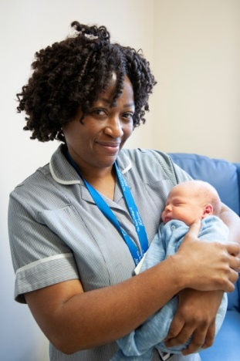

Support for Our Retiring Staff

Each year we run pre-retirement seminars for staff that are looking to retire within one to four years’ time. The seminars help staff to prepare and plan for their retirement and covers aims and concerns, financial matters, inflation, taxation, investments, wills and equity release.

In addition staff can also join the NHS Retirement Fellowship, which is a social, leisure, educational and welfare organisation for current and retired NHS and Social Care staff and their partners.

More than 17% of our workforce are over the age of 55, so these seminars prove useful for many of our staff.

Equality Analysis

We continued to analyse our policies and procedures, to ensure they meet our public sector duties and give ‘due regard’ to ensure that everyone who works here or uses our services are treated fairly, equally and free from discrimination.

From April 2019 to March 2020 we analysed 73 procedural documents.

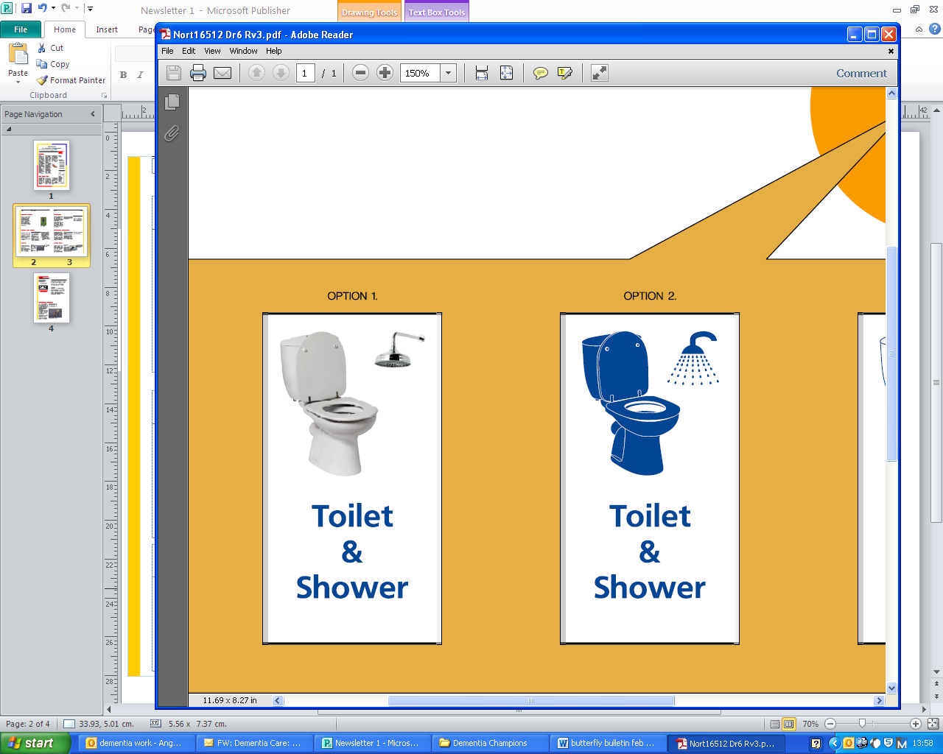Equality & Diversity Group – Workforce

Our Equality and Diversity Staff Group (EDSG) continued to meet on a quarterly basis. The purpose of the group is to champion and steer the work of the hospital so that we are in full and positive compliance of equality and human rights legislation, regulations and codes of practice including NHS and Department of Health standards.

The aim of the group is twofold, firstly to lead, advise and inform on all aspects of policy making, and employment including various engagements related to equality

and inclusion legislation and policy direction. The second EDSGaim is to lead and monitor progress on the development of the Equality Objectives/Four Year Plan. The two main objectives link to the Equality Delivery System (ED2) outcomes relating to

the workforce:

1. A representative and supported workforce –

*“We will improve our staff satisfaction rates as reported in the annual staff survey.*

*We will make year on year improvements on our staff survey results, aiming to*

*achieve top 20% of acute Trusts for staff engagement. We will improve the experiences and treatment between White staff and BME staff at the Trust by progressing the Workforce Race Equality Standard (WRES) and monitoring outcomes.”*

1. Inclusive leadership -

“We will improve our leadership and management capability.”

The key actions for each objective are linked to the Workforce Race Equality Standard (WRES), Workforce Disability Equality Standard (WDES), Gender Pay Gap reporting and the staff survey results.

During 2020/2021 we will be reviewing our key actions to ensure that they are fit for purpose, meet the needs of the Trust, and continue to link to our analysis and findings from our most recent staff survey results and our findings from the annual WRES, WDES and Gender Pay Gap Reporting exercises.

Workforce Race Equality Standard (WRES)

We undertook our fifth WRES exercise in 2019 and it was submitted to NHS England and published on our website in September 2019.

There was improvement in some areas from 2018, such as an increase in the number of Black, Asian & Minority Ethnic (BAME) staff who work for us, along with an increase in the likelihood that a BAME applicant would be appointed following shortlisting.

Deteriorations from the previous year were seen for BAME staff reporting bullying, harassment or discrimination and a reduction in the number of BME staff who believe we provide equal opportunities for career progression or promotion.

The National WRES Report was released in January 2020 and when comparing our results to the national results we have more positive results for some of the indicators. The areas where our results are below that of the national results is for the same areas where we have deteriorated since 2018.

Our WRES Data Reports can be found on our Trust website.



Workforce Disability Equality Standard (WDES)

2019 saw the introduction of the Workforce Disability Equality Standard (WDES).

This is a set of key indicators which we will be measured against, from the data we hold for staff, to compare the experiences and treatment of our disabled staff compared to our non-disabled staff.

As this is the first time the data has been collected we are not able to make a

historical comparison to assess if there have been improvements or deteriorations,

so this will be undertaken the next time the data is collected.

The National WDES Report was released in March 2020 and when comparing our results to the national results we have more positive results for some of the indicators, such as the number of disabled staff entering a formal capability process when compared to non-disabled staff and the percentage of staff who felt adequate reasonable adjustments had been made to enable them to carry out their work.

The areas where we had less positive results than those nationally were around bullying, harassment or discrimination and disabled staff who believe we provide

equal opportunities for career progression or promotion.

Our WDES Data Reports can be found on our Trust website.

[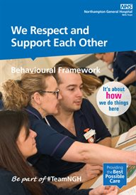](http://thestreet/WorkingLife/Respect-and-Support/Downloads/Respect-and-Support-booklet-v5-Jun-18-NGV2090.pdf)

Gender Pay Gap Reporting

As per the Equality Act 2010 (Gender Pay Gap Information Regulations 2017) we compiled our data for the third time, since the regulations came into effect. In February 2020 the approved report was published on our website and submitted to the Government. Although we are not legally required to produce a written report it was agreed we would do this to give context to the data. The report can be found on our website:

<https://www.northamptongeneral.nhs.uk/About/Equality-and-diversity-information/Equality-Diversity-Inclusion.aspx>

There has been a deterioration when comparing it to the results of the previous year and we will be looking at the results more closely during 2020/2021 to see what we can do to reduce the gap.

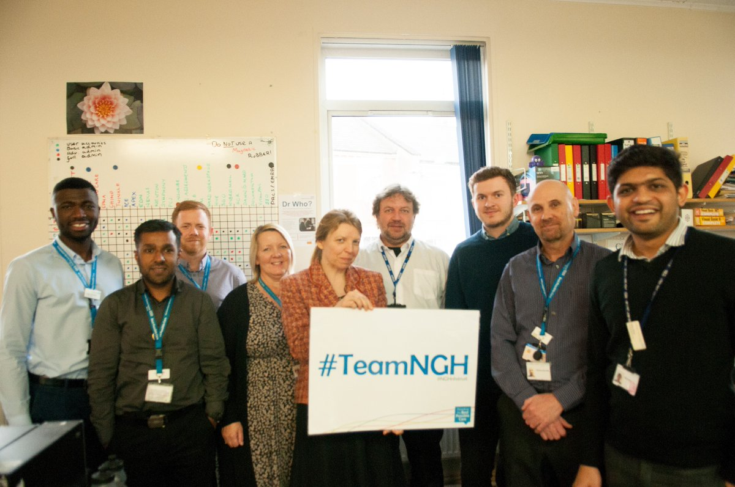

Staff Survey 2019 Equality & Diversity Results

The 2019 annual National NHS Staff Survey took place during October to December

2019 and 2,027 members of staff returned the survey. Of the 11 themes there was deterioration in seven and five stayed the same.

The overall Equality & Diversity theme deteriorated in 2019 from 8.9 in 2018 to 8.8

out of 10.

Within the Staff Survey there are four specific questions about equality and diversity.

The first question is in relation to the percentage of staff believing that we act fairly in relation to career progression and promotion. This result has deteriorated from 83.5%

in 2018 to 80.7% in 2019. We are also below average when compared to other acute

trusts by 3.7%.

The question relating to personally experiencing discrimination at work in the last 12

months from patients/service users, their relatives or other members of the public has deteriorated from 8.5% in 2018 to 9.8% in 2019. The national average when compared

to other acute trusts is 6.8%.

The same question, but relating to discrimination from managers, team leaders or other colleagues was 10.2% in 2018 and has increased slightly to 10.4%. We are also worse than the national average which is 7.5%

There was a slight improvement for the final question that asks if adequate adjustments have been made in order to enable staff to carry out their work. Our 2018 result was

76% rising to 76.3% in 2019. We are also better than the national average for acute

trusts which is 73.4%.

The survey has highlighted some areas of concern and we will be working with our

teams to analyse the results more deeply in order to continue our work in ensuring all

our staff are focused on our values, by displaying positive behaviours, high quality care and striving for continuous improvement and meaningful staff engagement to sustainably improve staff satisfaction at work.

Disability Confident Scheme Certification

We continue to be certified as a Disability Confident Employer (formally Positive about Disabled People ‘Two Ticks’ Scheme) and as a result of this we commit to:

* Get the right people for our organisation - which includes providing fully inclusive and accessible recruitment processes, offering interviews to disabled people who meet the minimum criteria for the job and making reasonable adjustments as required.
* Keep and develop our staff - which includes supporting our staff to manage their disabilities or health conditions.

Along with ensuring that our recruitment processes are accessible and fair, we also encouraged our existing staff, that have a disability, to make us aware so that we could meet with them and discuss what support could be provided, if required. Knowing which of our staff have a disability also enables us to record the number of disabled staff that we have and the nature of their disability, in line with the Data Protection Act.

It is our ultimate goal is to attain the next level of certification, which is a Disability Confident Leader.

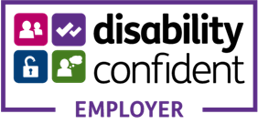

Faith and Belief

As one of the largest employers in Northampton our staff have many different religious beliefs, some of which have specific festival periods or Holy Days throughout the year.

Although there is no right that guarantees staff time off to attend religious services, we

do recognise that it is good practice to accommodate requests where possible. To

support with this we have been making our managers aware of key dates for religious observance and providing them with information to help them better understand the

needs of our staff in relation to their religion or beliefs.

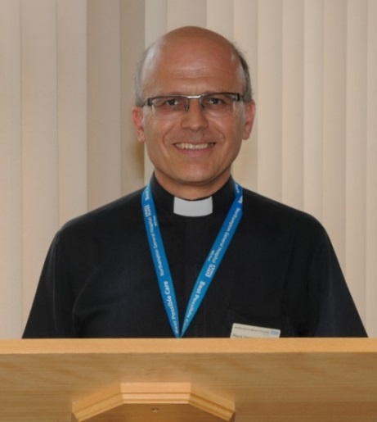The hospital has two chaplains and a team of 12 volunteer pastoral visitors. The chaplains

regularly visit the wards and are always happy to

offer support or a ‘listening ear’. Hospital Chaplains have a duty of care not only for the patients, but

also the whole hospital community, including staff, visitors and friends.

A Hospital Chaplain is always available to support people in their religious and spiritual journey. The Chapel is always open and can offer a refuge and sanctuary for prayer, reflection and meditation for

staff, patients and visitors.

Health and Well Being for Staff

The working environment of an acute Trust is demanding and can be pressurised, therefore promoting a culture of health and wellbeing in our organisation has never been more important. Our staff are our biggest asset, they are committed to patient care and their physical and emotional wellbeing is key.

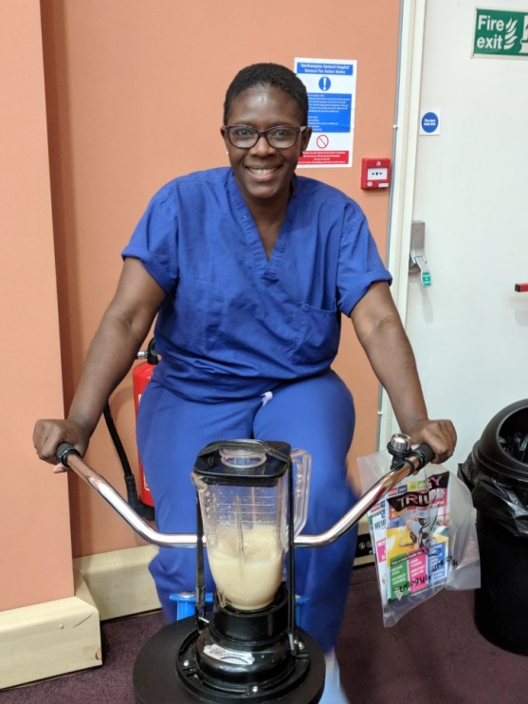Over the past 12 months we have promoted a range of opportunities for staff to improve and invest in their health and wellbeing. We have provided practical options for staff to participate in, with the emphasis of providing them with visible and tangible initiatives to highlight the importance the hospital places on the wellbeing of our staff.

During the Trust response to COVID-19 our efforts focused on the mental well-being of staff and how we could support them to enable them to continue to deliver the best possible care to our patients and to look after themselves and their colleagues.

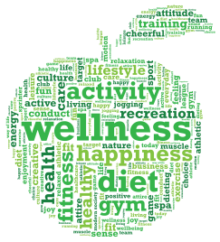

cid:image012.png@01D504F5.03C18350

Our Workforce Data

As at 31 March 2020 the Trust employed 5457 members of staff, which was a whole time equivalent of 4801.35 people.

By Staff Group breakdown is as follows:

|  |  |  |
| --- | --- | --- |
| **Staff Group (as at 31/3/20)** | **Headcount** | **%** |
| Nursing and Midwifery Registered | 1616 | 29.61 |
| Administrative and Clerical | 1160 | 21.26 |
| Additional Clinical Services | 1010 | 18.51 |
| Medical and Dental | 580 | 10.63 |
| Estates and Ancillary | 549 | 10.06 |
| Allied Health Professionals | 248 | 4.54 |
| Add Prof Scientific and Technic | 161 | 2.95 |
| Healthcare Scientists | 133 | 2.44 |
| **Total** | **5457** | **100%** |

|  |
| --- |
| **Age** |

**Age - Trust Profile**

The overall age profile for the Trust is shown in the table below:

|  |  |  |
| --- | --- | --- |
| **Age Profile (as at 31/3/20)** | **Headcount** | **%** |
| 0-20 | 100 | 1.83 |
| 21-25 | 389 | 7.13 |
| 26-30 | 784 | 14.36 |
| 30-35 | 718 | 13.15 |
| 36-40 | 610 | 11.18 |
| 41-45 | 656 | 12.02 |
| 46-50 | 622 | 11.39 |
| 51-55 | 611 | 11.20 |
| 56-60 | 574 | 10.52 |
| 61-65 | 305 | 5.59 |
| 66-70 | 64 | 1.19 |
| 71 & Over | 24 | 0.44 |
| **Total** | **5457** | **100%** |

The highest percentage of staff employed by the Trust are in the age ranges of 26-30 and 30-35. The lowest percentage of staff employed are in the age ranges of 71 and over and 66-70.

**Age by Pay Band**

|  |  |  |  |  |
| --- | --- | --- | --- | --- |
| **Band** | **Age Group** | **Total** | **%** | **All Staff %** |
| Bands 4 and Below | Under 20 | 100 | 4.23% | 1.83% |
| 21-25 | 210 | 8.89% | 7.11% |
| 26-30 | 267 | 11.30% | 14.39% |
| 31-35 | 256 | 10.83% | 13.16% |
| 36-40 | 244 | 10.33% | 11.18% |
| 41-45 | 217 | 9.18% | 12.02% |
| 46-50 | 258 | 10.92% | 11.40% |
| 51-55 | 286 | 12.10% | 11.20% |
| 56-60 | 289 | 12.23% | 10.52% |
| Over 61 | 236 | 9.99% | 7.19% |
| **Total** | **2363** | 100.00% |  |
| Bands 5-7 | Under 20 | 0 | 0.00% | 1.83% |
| 21-25 | 147 | 6.42% | 7.11% |
| 26-30 | 394 | 17.21% | 14.39% |
| 31-35 | 349 | 15.25% | 13.16% |
| 36-40 | 272 | 11.88% | 11.18% |
| 41-45 | 323 | 14.11% | 12.02% |
| 46-50 | 256 | 11.18% | 11.40% |
| 51-55 | 225 | 9.83% | 11.20% |
| 56-60 | 209 | 9.13% | 10.52% |
| Over 61 | 115 | 5.02% | 7.19% |
| **Total** | **2289** | 100.04% |  |
| Band 8 and Above including VSM | Under 20 | 0 | 0.00% | 1.83% |
| 21-25 | 0 | 0.00% | 7.11% |
| 26-30 | 7 | 3.11% | 14.39% |
| 31-35 | 19 | 8.44% | 13.16% |
| 36-40 | 20 | 8.89% | 11.18% |
| 41-45 | 39 | 17.33% | 12.02% |
| 46-50 | 42 | 18.67% | 11.40% |
| 51-55 | 47 | 20.89% | 11.20% |
| 56-60 | 35 | 15.56% | 10.52% |
| Over 61 | 16 | 7.11% | 7.19% |
| **Total** | **225** | 100.00% |  |
| Medical & Dental | Under 20 | 0 | 0.00% | 1.83% |
| 21-25 | 32 | 5.52% | 7.11% |
| 26-30 | 117 | 20.17% | 14.39% |
| 31-35 | 94 | 16.21% | 13.16% |
| 36-40 | 74 | 12.76% | 11.18% |
| 41-45 | 77 | 13.28% | 12.02% |
| 46-50 | 66 | 11.38% | 11.40% |
| 51-55 | 53 | 9.14% | 11.20% |
| 56-60 | 41 | 7.07% | 10.52% |
| Over 61 | 26 | 4.48% | 7.19% |
| **Total** | **580** | 100.00% |  |

**Age by New Starters**

Between 1 April 2019 and 31 March 2020 there were 1078 new starters at the Trust, which represents 19.75% of the workforce.

|  |  |  |
| --- | --- | --- |
| **Age Profile of New Starters (as at 31/3/20)** | **Headcount** | **%** |
| 0-20 | 77 | 7.14 |
| 21-25 | 174 | 16.14 |
| 26-30 | 233 | 21.62 |
| 30-35 | 185 | 17.16 |
| 36-40 | 105 | 9.74 |
| 41-45 | 106 | 9.83 |
| 46-50 | 81 | 7.51 |
| 51-55 | 56 | 5.19 |
| 56-60 | 43 | 3.99 |
| 61-65 | 16 | 1.48 |
| 66-70 | 1 | 0.10 |
| 71 & Over | 1 | 0.10 |
| **Total** | **1078** | **100%** |

**Age by Leavers**

Between 1 April 2019 and 31 March 2020 there were 636 leavers from the Trust, which represents 11.65% of the workforce.

|  |  |  |
| --- | --- | --- |
| **Age Profile of Leavers (as at 31/3/20)** | **Headcount** | **%** |
| 0-20 | 19 | 2.99 |
| 21-25 | 66 | 10.38 |
| 26-30 | 138 | 21.7 |
| 30-35 | 84 | 13.21 |
| 36-40 | 72 | 11.32 |
| 41-45 | 54 | 8.49 |
| 46-50 | 53 | 8.33 |
| 51-55 | 44 | 6.92 |
| 56-60 | 50 | 7.86 |
| 61-65 | 45 | 7.07 |
| 66-70 | 6 | 0.94 |
| 71 & Over | 5 | 0.79 |
| **Total** | **636** | **100%** |

|  |
| --- |
| **Disability** |

**Disability - Trust Profile**

The overall disability profile for the Trust is shown in the table below:

|  |  |  |
| --- | --- | --- |
| **Disability Profile (as at 31/3/20)** | **Headcount** | **%** |
| No | 4283 | 78.49 |
| Unspecified | 660 | 12.09 |
| Not Declared | 334 | 6.12 |
| Yes | 174 | 3.19 |
| Prefer Not to Answer | 6 | 0.11 |
| **Total** | **5457** | **100%** |

The highest percentage of staff employed by the Trust have declared they do not have a disability. The lowest percentage of staff employed have indicated they would prefer not to answer or have declared they have a disability.

**Disability by Pay Band**

|  |  |  |  |  |
| --- | --- | --- | --- | --- |
| **Band** | **Disability** | **Total** | **%** | **All Staff %** |
| Bands 4 and Below | No | 1908 | 80.75% | 78.50% |
| Not Declared | 83 | 3.51% | 6.12% |
| Prefer Not to Answer | 2 | 0.08% | 0.11% |
| Unspecified | 284 | 12.02% | 12.10% |
| Yes | 86 | 3.64% | 3.17% |
| **Total** | **2363** | **100%** |  |
| Bands 5-7 | No | 1815 | 79.29% | 78.50% |
| Not Declared | 123 | 5.37% | 6.12% |
| Prefer Not to Answer | 4 | 0.17% | 0.11% |
| Unspecified | 267 | 11.66% | 12.10% |
| Yes | 80 | 3.49% | 3.17% |
| **Total** | **2289** | **100%** |  |
| Band 8 and Above including VSM | No | 175 | 77.78% | 78.50% |
| Not Declared | 9 | 4.00% | 6.12% |
| Prefer Not to Answer | 0 | 0.00% | 0.11% |
| Unspecified | 40 | 17.78% | 12.10% |
| Yes | 1 | 0.44% | 3.17% |
| **Total** | **225** | **100%** |  |
| Medical & Dental | No | 385 | 66.38% | 78.50% |
| Not Declared | 119 | 20.52% | 6.12% |
| Prefer Not to Answer | 0 | 0.00% | 0.11% |
| Unspecified | 69 | 11.90% | 12.10% |
| Yes | 7 | 1.21% | 3.17% |
| **Total** | **580** | **100%** |  |

**Disability by New Starters**

Between 1 April 2019 and 31 March 2020 there were 1078 new starters at the Trust, which represents 19.75% of the workforce.

|  |  |  |
| --- | --- | --- |
| **Disability Profile of New Starters (as at 31/3/20)** | **Headcount** | **%** |
| No | 876 | 81.26 |
| Not Declared | 83 | 7.70 |
| Prefer Not to Answer | 3 | 0.28 |
| Unspecified | 76 | 7.05 |
| Yes | 40 | 3.71 |
| **Total** | **1078** | **100%** |

**Disability by Leavers**

Between 1 April 2019 and 31 March 2020 there were 636 leavers from the Trust, which represents 11.65% of the workforce.

|  |  |  |
| --- | --- | --- |
| **Disability Profile of Leavers (as at 31/3/20)** | **Headcount** | **%** |
| No | 511 | 80.34 |
| Not Declared | 51 | 8.02 |
| Unspecified | 45 | 7.08 |
| Yes | 29 | 4.56 |
| **Total** | **636** | **100%** |

|  |
| --- |
| **Ethnicity** |

**Ethnicity - Trust Profile**

The overall ethnicity profile for the Trust is shown in the table below:

|  |  |  |
| --- | --- | --- |
| **Ethnicity Profile (as at 31/3/20)** | **Headcount** | **%** |
| White | 3912 | 71.70 |
| Asian | 774 | 14.18 |
| Black | 374 | 6.85 |
| Not Stated / Specified | 212 | 3.88 |
| Other | 97 | 1.78 |
| Mixed | 88 | 1.61 |
| **Total** | **5457** | **100%** |

The highest percentage of staff employed by the Trust are White. The lowest percentage of staff employed are Mixed or Other.

**Ethnicity by Pay Band**

|  |  |  |  |  |
| --- | --- | --- | --- | --- |
| **Band** | **Disability** | **Total** | **%** | **All Staff %** |
| Bands 4 and Below | White | 1955 | 82.74% | 71.70% |
| Asian | 161 | 6.81% | 14.18% |
| Black | 134 | 5.67% | 6.85% |
| Mixed | 39 | 1.65% | 1.61% |
| Not Stated / Specified | 48 | 2.03% | 3.88% |
| Other | 26 | 1.10% | 1.78% |
| **Total** | **2363** | **100%** |  |
| Bands 5-7 | White | 1564 | 68.33% | 71.70% |
| Asian | 388 | 16.95% | 14.18% |
| Black | 198 | 8.65% | 6.85% |
| Mixed | 33 | 1.44% | 1.61% |
| Not Stated / Specified | 69 | 3.01% | 3.88% |
| Other | 37 | 1.62% | 1.78% |
| **Total** | **2289** | **100%** |  |
| Band 8 and Above including VSM | White | 193 | 85.78% | 71.70% |
| Asian | 13 | 5.77% | 14.18% |
| Black | 8 | 3.56% | 6.85% |
| Mixed | 2 | 0.89% | 1.61% |
| Not Stated / Specified | 5 | 2.22% | 3.88% |
| Other | 4 | 1.78% | 1.78% |
| **Total** | **225** | **100%** |  |
| Medical & Dental | White | 200 | 34.49% | 71.70% |
| Asian | 212 | 36.55% | 14.18% |
| Black | 34 | 5.86% | 6.85% |
| Mixed | 14 | 2.41% | 1.61% |
| Not Stated / Specified | 90 | 15.52% | 3.88% |
| Other | 30 | 5.17% | 1.78% |
| **Total** | **580** | **100%** |  |

**Ethnicity by New Starters**

Between 1 April 2019 and 31 March 2020 there were 1078 new starters at the Trust, which represents 19.75% of the workforce.

|  |  |  |
| --- | --- | --- |
| **Age Profile of New Starters (as at 31/3/20)** | **Headcount** | **%** |
| White | 565 | 52.42 |
| Asian | 21 | 1.95 |
| Black | 207 | 19.20 |
| Mixed | 110 | 10.20 |
| Other | 29 | 2.69 |
| Not Stated / Specified | 146 | 13.54 |
| **Total** | **1078** | **100%** |

**Ethnicity by Leavers**

Between 1 April 2019 and 31 March 2020 there were 636 leavers from the Trust, which represents 11.65% of the workforce.

|  |  |  |
| --- | --- | --- |
| **Ethnicity Profile of Leavers (as at 31/3/20)** | **Headcount** | **%** |
| White | 378 | 59.44 |
| Asian | 136 | 21.38 |
| Black | 45 | 7.08 |
| Mixed | 18 | 2.83 |
| Other | 31 | 4.87 |
| Not Stated / Specified | 28 | 4.40 |
| **Total** | **636** | **100%** |

|  |
| --- |
| **Marital Status** |

**Marital Status - Trust Profile**

The overall marital status profile for the Trust is shown in the table below:

|  |  |  |
| --- | --- | --- |
| **Marital Status Profile (as at 31/3/20)** | **Headcount** | **%** |
| Married | 2799 | 51.30 |
| Single | 1872 | 34.30 |
| Divorced | 347 | 6.36 |
| Unknown | 287 | 5.26 |
| Civil Partnership | 54 | 0.99 |
| Legally Separated | 52 | 0.95 |
| Widowed | 46 | 0.84 |
| **Total** | **5457** | **100%** |

The highest percentage of staff employed by the Trust are married. The lowest percentage of staff employed are widowed or legally separated.

**Marital Status by Pay Band**

|  |  |  |  |  |
| --- | --- | --- | --- | --- |
| **Band** | **Disability** | **Total** | **%** | **All Staff %** |
| Bands 4 and Below | Civil Partnership | 34 | 1.44 | 0.99 |
| Divorced | 194 | 8.21 | 6.36 |
| Legally Separated | 37 | 1.57 | 0.95 |
| Married | 1065 | 45.06 | 51.3 |
| Single | 932 | 39.44 | 34.3 |
| Unknown | 54 | 2.29 | 5.26 |
| Widowed | 47 | 1.99 | 0.84 |
| **Total** | **2363** | **100%** |  |
| Bands 5-7 | Civil Partnership | 17 | 0.74 | 0.99 |
| Divorced | 126 | 5.5 | 6.36 |
| Legally Separated | 13 | 0.57 | 0.95 |
| Married | 1262 | 55.14 | 51.3 |
| Single | 793 | 34.64 | 34.3 |
| Unknown | 67 | 2.93 | 5.26 |
| Widowed | 11 | 0.48 | 0.84 |
| **Total** | **2289** | **100%** |  |
| Band 8 and Above including VSM | Civil Partnership | 3 | 1.33 | 0.99 |
| Divorced | 16 | 7.11 | 6.36 |
| Legally Separated | 1 | 0.45 | 0.95 |
| Married | 153 | 68 | 51.3 |
| Single | 41 | 18.22 | 34.3 |
| Unknown | 10 | 4.44 | 5.26 |
| Widowed | 1 | 0.45 | 0.84 |
| **Total** | **225** | **100%** |  |
| Medical & Dental | Civil Partnership | 0 | 0 | 0.99 |
| Divorced | 11 | 1.9 | 6.36 |
| Legally Separated | 1 | 0.17 | 0.95 |
| Married | 319 | 55 | 51.3 |
| Single | 106 | 18.28 | 34.3 |
| Unknown | 141 | 24.31 | 5.26 |
| Widowed | 2 | 0.34 | 0.84 |
| **Total** | **580** | **100%** |  |

**Marital Status by New Starters**

Between 1 April 2019 and 31 March 2020 there were 1078 new starters at the Trust, which represents 19.75% of the workforce.

|  |  |  |
| --- | --- | --- |
| **Marital Status Profile of New Starters (as at 31/3/20)** | **Headcount** | **%** |
| Civil Partnership | 17 | 1.58 |
| Divorced | 45 | 4.17 |
| Legally Separated | 4 | 0.37 |
| Married | 393 | 36.46 |
| Single | 476 | 44.16 |
| Unknown | 139 | 12.89 |
| Widowed | 4 | 0.37 |
| **Total** | **1078** | **100%** |

**Marital Status by Leavers**

Between 1 April 2019 and 31 March 2020 there were 636 leavers from the Trust, which represents 11.65% of the workforce.

|  |  |  |
| --- | --- | --- |
| **Marital Status Profile of Leavers (as at 31/3/20)** | **Headcount** | **%** |
| Civil Partnership | 10 | 1.57 |
| Divorced | 34 | 5.35 |
| Legally Separated | 7 | 1.10 |
| Married | 266 | 43.72 |
| Single | 278 | 43.71 |
| Unknown | 38 | 5.97 |
| Widowed | 3 | 0.47 |
| **Total** | **636** | **100%** |

|  |
| --- |
| **Maternity** |

**Maternity Status - Trust Profile**

The overall maternity status profile for the Trust, including paternity leave and shared parental leave is shown in the table below:

|  |  |  |
| --- | --- | --- |
| **Marital Status Profile (as at 31/3/20)** | **Headcount** | **% of Trust Staff** |
| Maternity Leave | 200 | 3.67 |
| Paternity Leave | 30 | 0.55 |
| Shared Parental Leave | 1 | 0.02 |
| Adoption Leave | 0 | 0.00 |
| **Total** | **231** | **4.24** |

The highest percentage of staff on parenting leave are on maternity leave.

|  |
| --- |
| **Religious Belief** |

**Religious Belief - Trust Profile**

The overall religious belief profile for the Trust is shown in the table below:

|  |  |  |
| --- | --- | --- |
| **Religious Belief Profile (as at 31/3/20)** | **Headcount** | **%** |
| Christianity | 2670 | 48.93 |
| I Do Not Wish to Disclose | 886 | 16.24 |
| Atheism | 674 | 12.35 |
| Other | 464 | 8.50 |
| Unspecified | 338 | 6.19 |
| Hinduism | 191 | 3.50 |
| Islam | 170 | 3.12 |
| Buddhism | 35 | 0.64 |
| Sikhism | 17 | 0.31 |
| Jainism | 7 | 0.13 |
| Judaism | 5 | 0.09 |
| **Total** | **5457** | **100%** |

The highest percentage of staff employed by the Trust are Christian. The religious beliefs of the lowest percentage of staff employed are Judaism and Jainism.

**Religious Belief by Pay Band**

|  |  |  |  |  |
| --- | --- | --- | --- | --- |
| **Band** | **Religious Belief** | **Total** | **%** | **All Staff %** |
| Bands 4 and Below | Atheism | 324 | 13.71 | 12.35 |
| Buddhism | 11 | 0.47 | 0.64 |
| Christianity | 1178 | 49.86 | 49.93 |
| Hinduism | 32 | 1.34 | 3.50 |
| Not Disclosed | 372 | 15.75 | 16.24 |
| Islam | 38 | 1.61 | 3.12 |
| Jainism | 1 | 0.04 | 0.13 |
| Judaism | 0 | 0.00 | 0.09 |
| Other | 262 | 11.09 | 8.50 |
| Sikhism | 5 | 0.21 | 0.31 |
| Unspecified | 140 | 5.92 | 6.19 |
| **Total** | **2363** | 100.00% |  |
| Bands 5-7 | Atheism | 274 | 11.97 | 12.35 |
| Buddhism | 7 | 0.31 | 0.64 |
| Christianity | 1247 | 54.47 | 49.93 |
| Hinduism | 63 | 2.75 | 3.50 |
| Not Disclosed | 347 | 15.16 | 16.24 |
| Islam | 40 | 1.75 | 3.12 |
| Jainism | 3 | 0.13 | 0.13 |
| Judaism | 2 | 0.09 | 0.09 |
| Other | 175 | 7.65 | 8.50 |
| Sikhism | 6 | 0.26 | 0.31 |
| Unspecified | 125 | 5.46 | 6.19 |
| **Total** | **2289** | 100.00% |  |
| Band 8 and Above including VSM | Atheism | 30 | 13.34 | 12.35 |
| Buddhism | 1 | 0.44 | 0.64 |
| Christianity | 123 | 54.68 | 49.93 |
| Hinduism | 5 | 2.22 | 3.50 |
| Not Disclosed | 28 | 12.44 | 16.24 |
| Islam | 3 | 1.33 | 3.12 |
| Jainism | 1 | 0.44 | 0.13 |
| Judaism | 0 | 0.00 | 0.09 |
| Other | 16 | 7.11 | 8.50 |
| Sikhism | 1 | 0.44 | 0.31 |
| Unspecified | 17 | 7.56 | 6.19 |
| **Total** | **225** | 100.00% |  |
| Medical & Dental | Atheism | 46 | 7.93 | 12.35 |
| Buddhism | 16 | 2.76 | 0.64 |
| Christianity | 122 | 21.03 | 49.93 |
| Hinduism | 91 | 15.69 | 3.50 |
| Not Disclosed | 139 | 23.97 | 16.24 |
| Islam | 89 | 15.34 | 3.12 |
| Jainism | 2 | 0.34 | 0.13 |
| Judaism | 3 | 0.52 | 0.09 |
| Other | 11 | 1.90 | 8.50 |
| Sikhism | 5 | 0.86 | 0.31 |
| Unspecified | 56 | 9.66 | 6.19 |
| **Total** | **580** | 100.00% |  |

**Religious Belief by New Starters**

Between 1 April 2019 and 31 March 2020 there were 1078 new starters at the Trust, which represents 19.75% of the workforce.

|  |  |  |
| --- | --- | --- |
| **Religious Belief Profile of New Starters (as at 31/3/20)** | **Headcount** | **%** |
| Atheism | 159 | 14.75 |
| Buddhism | 13 | 1.21 |
| Christianity | 431 | 39.99 |
| Hinduism | 60 | 5.57 |
| Not Disclosed | 247 | 22.91 |
| Islam | 70 | 6.49 |
| Jainism | 1 | 0.09 |
| Judaism | 1 | 0.09 |
| Other | 90 | 8.35 |
| Sikhism | 5 | 0.46 |
| Unspecified | 1 | 0.09 |
| **Total** | **1078** | **100%** |

**Religious Belief by Leavers**

Between 1 April 2019 and 31 March 2020 there were 636 leavers from the Trust, which represents 11.65% of the workforce.

|  |  |  |
| --- | --- | --- |
| **Religious Belief Profile of Leavers (as at 31/3/20)** | **Headcount** | **%** |
| Atheism | 85 | 13.36 |
| Buddhism | 8 | 1.26 |
| Christianity | 256 | 40.25 |
| Hinduism | 46 | 7.23 |
| Not Disclosed | 101 | 15.88 |
| Islam | 62 | 9.75 |
| Jainism | 1 | 0.16 |
| Judaism | 1 | 0.16 |
| Other | 42 | 6.60 |
| Sikhism | 12 | 1.89 |
| Unspecified | 22 | 3.46 |
| **Total** | **636** | **100%** |

|  |
| --- |
| **Sex/Gender** |

**Sex/Gender - Trust Profile**

The overall sex/gender profile for the Trust is shown in the table below:

|  |  |  |
| --- | --- | --- |
| **Sex/Gender Profile (as at 31/3/20)** | **Headcount** | **%** |
| Female | 4324 | 79.24 |
| Male | 1133 | 20.76 |
| **Total** | **5457** | **100%** |

The highest percentage of staff employed by the Trust are female.

**Sex/Gender by Pay Band**

|  |  |  |  |  |
| --- | --- | --- | --- | --- |
| **Band** | **Disability** | **Total** | **%** | **All Staff %** |
| Bands 4 and Below | Female | 1918 | 81.17 | 79.24 |
| Male | 445 | 18.83 | 20.76 |
| **Total** | **2363** | **100%** |  |
| Bands 5-7 | Female | 1992 | 87.02 | 79.24 |
| Male | 297 | 12.98 | 20.76 |
| **Total** | **2289** | **100%** |  |
| Band 8 and Above including VSM | Female | 164 | 72.89 | 79.24 |
| Male | 61 | 27.11 | 20.76 |
| **Total** | **225** | **100%** |  |
| Medical & Dental | Female | 250 | 43.10 | 79.24 |
| Male | 330 | 56.90 | 20.76 |
| **Total** | **580** | **100%** |  |

**Sex/Gender by New Starters**

Between 1 April 2019 and 31 March 2020 there were 1078 new starters at the Trust, which represents 19.75% of the workforce.

|  |  |  |
| --- | --- | --- |
| **Sex/Gender Profile of New Starters (as at 31/3/20)** | **Headcount** | **%** |
| Female | 778 | 72.17 |
| Male | 300 | 27.83 |
| **Total** | **1078** | **100%** |

**Sex/Gender by Leavers**

Between 1 April 2019 and 31 March 2020 there were 636 leavers from the Trust, which represents 11.65% of the workforce.

|  |  |  |
| --- | --- | --- |
| **Sex/Gender Profile of Leavers (as at 31/3/20)** | **Headcount** | **%** |
| Female | 430 | 67.61 |
| Male | 206 | 32.39 |
| **Total** | **636** | **100%** |

|  |
| --- |
| **Sexual Orientation** |

**Sexual Orientation - Trust Profile**

The overall sexual orientation profile for the Trust is shown in the table below:

|  |  |  |
| --- | --- | --- |
| **Sex/Gender Profile (as at 31/3/20)** | **Headcount** | **%** |
| Heterosexual or Straight | 4285 | 78.52 |
| Not Stated | 696 | 12.75 |
| Unspecified | 365 | 6.69 |
| Gay or Lesbian | 62 | 1.14 |
| Bisexual | 47 | 0.86 |
| Other Sexual Orientation | 2 | 0.04 |
| **Total** | **5457** | **100%** |

The highest percentage of staff employed by the Trust are heterosexual or straight. The sexual orientation of the lowest percentage of staff employed is other sexual orientation and bisexual.

**Sexual Orientation by Pay Band**

|  |  |  |  |  |
| --- | --- | --- | --- | --- |
| **Band** | **Disability** | **Total** | **%** | **All Staff %** |
| Bands 4 and Below | Bisexual | 24 | 1.02 | 0.86 |
| Gay or Lesbian | 28 | 1.18 | 1.14 |
| Heterosexual or Straight | 1911 | 80.88 | 78.52 |
| Not stated | 247 | 10.45 | 12.75 |
| Other sexual orientation | 2 | 0.08 | 0.04 |
| Unspecified | 151 | 6.39 | 6.69 |
| **Total** | **2363** | **100%** |  |
| Bands 5-7 | Bisexual | 22 | 0.96 | 0.86 |
| Gay or Lesbian | 26 | 1.14 | 1.14 |
| Heterosexual or Straight | 1816 | 79.33 | 78.52 |
| Not stated | 288 | 12.58 | 12.75 |
| Other sexual orientation | 0 | 0 | 0.04 |
| Unspecified | 137 | 5.99 | 6.69 |
| **Total** | **2289** | **100%** |  |
| Band 8 and Above including VSM | Bisexual | 0 | 0 | 0.86 |
| Gay or Lesbian | 5 | 2.22 | 1.14 |
| Heterosexual or Straight | 180 | 80.00 | 78.52 |
| Not stated | 22 | 9.78 | 12.75 |
| Other sexual orientation | 0 | 0 | 0.04 |
| Unspecified | 18 | 8.00 | 6.69 |
| **Total** | **225** | **100%** |  |
| Medical & Dental | Bisexual | 1 | 0.17 | 0.86 |
| Gay or Lesbian | 4 | 0.69 | 1.14 |
| Heterosexual or Straight | 378 | 65.17 | 78.52 |
| Not stated | 139 | 23.97 | 12.75 |
| Other sexual orientation | 0 | 0 | 0.04 |
| Unspecified | 58 | 10.00 | 6.69 |
| **Total** | **580** | **100%** |  |

**Sexual Orientation by New Starters**

Between 1 April 2019 and 31 March 2020 there were 1078 new starters at the Trust, which represents 19.75% of the workforce.

|  |  |  |
| --- | --- | --- |
| **Sex/Gender Profile of New Starters (as at 31/3/20)** | **Headcount** | **%** |
| Bisexual | 10 | 0.93 |
| Gay or Lesbian | 18 | 1.67 |
| Heterosexual or Straight | 851 | 78.94 |
| Not stated | 193 | 17.90 |
| Other sexual orientation | 3 | 0.28 |
| Unspecified | 3 | 0.28 |
| **Total** | **1078** | **100%** |

**Sexual Orientation by Leavers**

Between 1 April 2019 and 31 March 2020 there were 636 leavers from the Trust, which represents 11.65% of the workforce.

|  |  |  |
| --- | --- | --- |
| **Sex/Gender Profile of Leavers (as at 31/3/20)** | **Headcount** | **%** |
| Bisexual | 2 | 0.31 |
| Gay or Lesbian | 11 | 1.73 |
| Heterosexual or Straight | 518 | 81.45 |
| Not stated | 79 | 12.42 |
| Other sexual orientation | 1 | 0.16 |
| Unspecified | 25 | 3.93 |
| **Total** | **636** | **100%** |

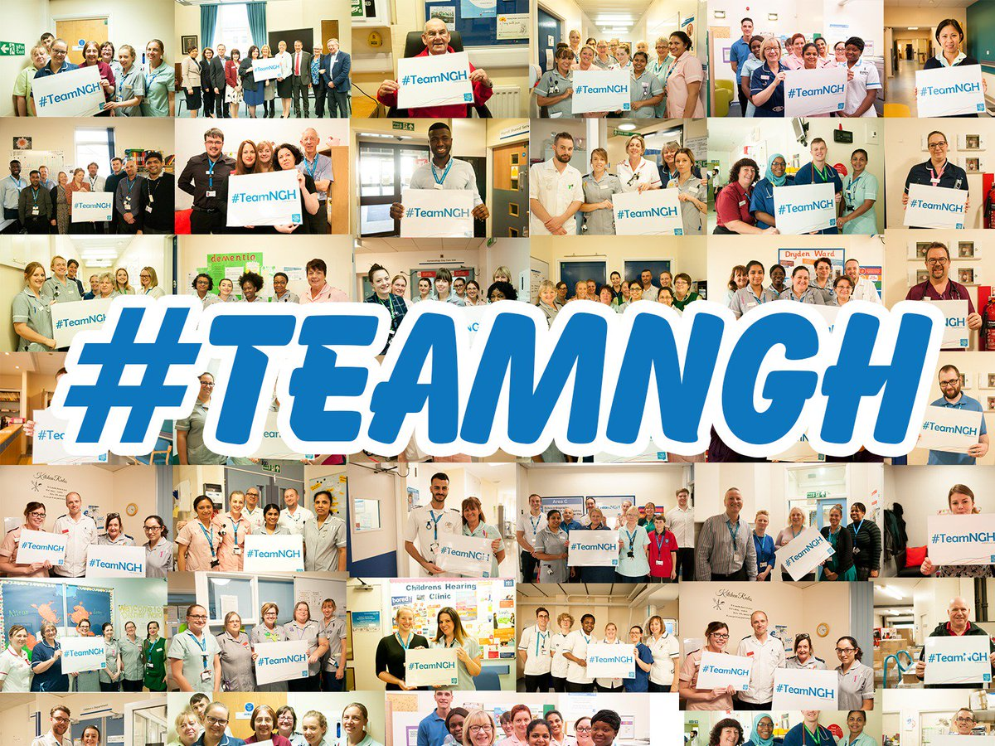

Northampton General Hospital

Our Contact Details are:

* Cliftonville, Northampton, NN1 5BD
* 01604 634700
* www.ngh.nhs.uk
* Find us on Facebook
* Follow us on Twitter @nghnhstrust
* Follow us on Instagram