**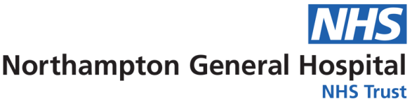****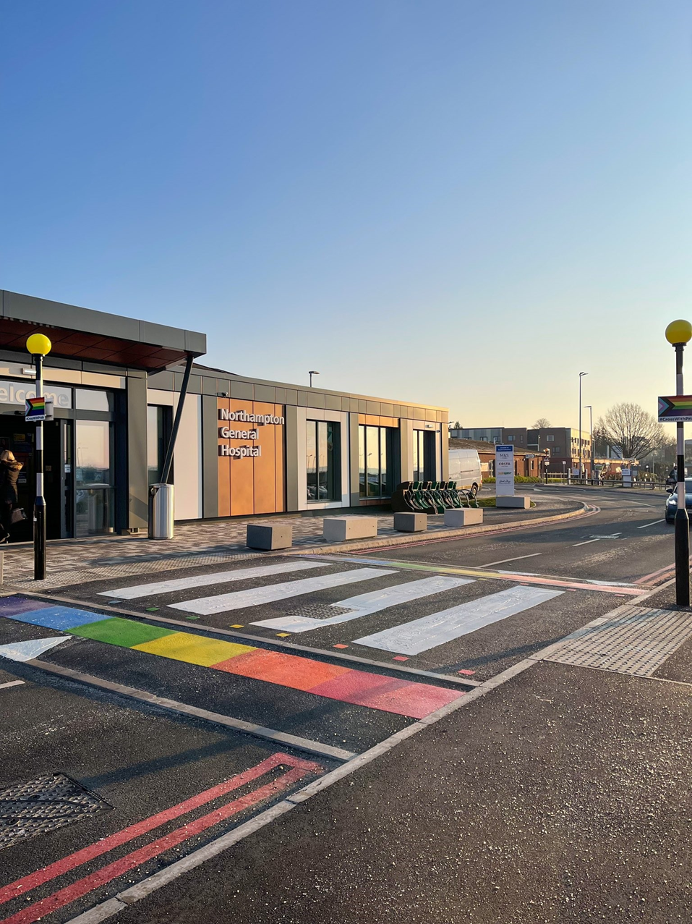**

**A photo of the entrance to Northampton General Hospital**

A photograph of the entrance to Kettering General Hospital

A photograph of the entrance to Kettering General Hospital

Equality, Diversity & Inclusion

Workforce Annual Report

April 2023 to March 2024

**Equality and Diversity**

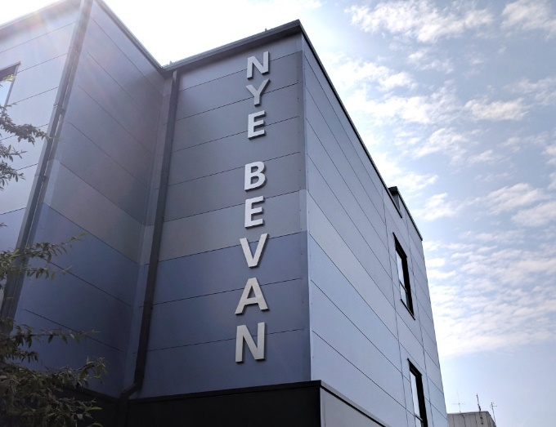

A photograph of the Nye Bevan building at Northampton General Hospital

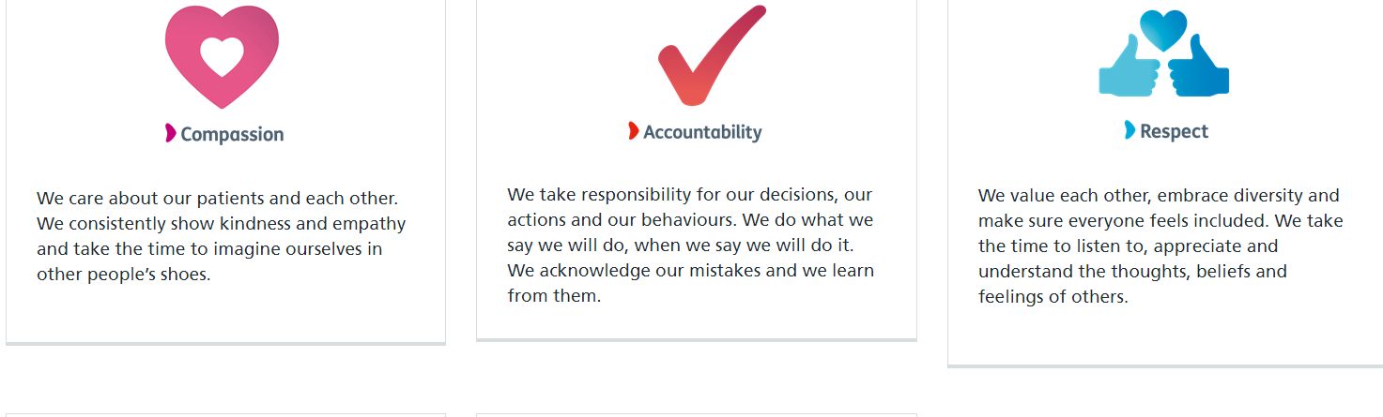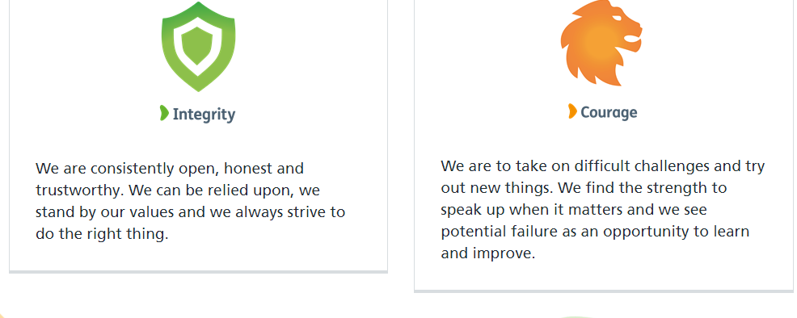Contents

Our Vision, Mission and Excellence Values

*Our Vision is -* Dedicated to outstanding patient care and staff experience by becoming a University Hospital Group and a leader in clinical excellence, inclusivity and collaborative healthcare.

*Our Mission is* - To provide safe, compassionate and clinically excellent patient care, by being an outstanding employer for our people, by creating opportunities, supporting innovation, and by working in partnership to improve local health and care services.

Executive Summary 4

Introduction – Our Strategic Aims 5

2023/2024 Summary 6

Our Population 7

Our Activities 9

Our Colleagues 17

Executive Summary

The Equality, Diversity and Inclusion Workforce Annual Report for 2023/2024 reviews the work Northampton General Hospital (NGH) has undertaken to promote equality, celebrate diversity create an inclusive workforce during April 2023 to March 2024.

Northampton General Hospital and Kettering General Hospital form the University Hospitals of Northamptonshire NHS Group which will enable us to work more closely together to provide our colleagues with a great place to work, which in turn, enables us to meet our Mission, Vision and Values during 2023/2024 and the years ahead.

In July 2021 we approved our 2021-24 Group Equality, Diversity & Inclusion Strategy, providing a real focus on the work that the Trust needs to undertake as part of its commitment to become a truly inclusive employer for our people and our patients.

We are determined and committed to improve the experiences of teams by driving the necessary changes for people to truly be united in making NGH the best it can be – a place where people feel valued, respected and empowered. We want to work to make sure we keep the amazing staff we have and support them to implement change and feel valued at work, where they can bring their whole selves to work and be celebrated for everything they are.

We are also committed to encouraging our teams to think differently and explore ideas with them on how we can make NGH the best place to work and receive care. We have established a number of staff networks to ensure that we celebrate and embrace the diversity of teams. Our REACH (Race, Ethnicity & Cultural Heritage), DAWN (Disability & Wellbeing Network) and PRIDE (LGBTQ+) networks all support colleagues to have their voices heard and provide a space for us to all learn and improve how we do things here.

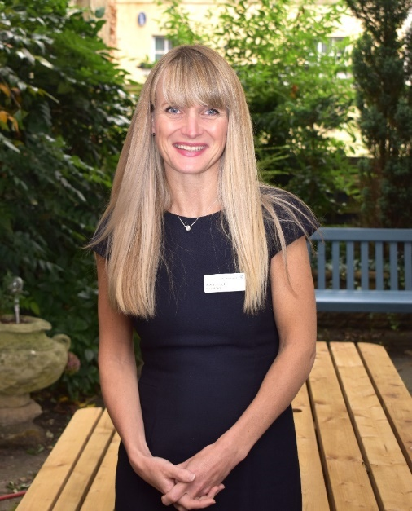 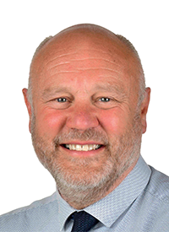

Heidi Smoult John MacDonald

*Hospital CEO* *Chairman*

**Introduction – Our Strategic Aims**

Equality, Diversity, and Inclusion (EDI) are key to achieving the Group vision of being “Dedicated to excellence in patient care and staff experience, and to becoming a leader in clinical excellence, inclusivity and collaborative healthcare.”

We believe that the Equality, Diversity, and Inclusion agenda is critical to building a future proof workforce that is truly reflective of the diverse communities we serve. We also believe that in building a diverse workforce, we will increase the talent pool from which we recruit and build services that are responsive to the needs of the local community.

We have agreed five priorities for the Group. Everything we do across both Northampton General Hospital NHS Trust and Kettering General Hospital NHS Foundation Trust should contribute towards achieving goals within at least one of these priority areas. They represent the long-term objectives of the Group, and each has an ambition and a success measure that we can track. Every year we will analyse our performance as a Group and set annual goals designed to make the biggest impact on each of these areas. Delivering our goals will move us closer towards achieving our overall vision.

* Patient - Excellent patient experience shaped by the patients' voice.
* Quality - Outstanding quality healthcare underpinned by continuous, patient-centred improvement and innovation.
* Systems and Partnerships - Seamless, timely pathways for all people's health needs, working together with our partners.
* Sustainability - A resilient and creative University Hospital Group, embracing every opportunity to improve care.
* People - An inclusive place to work where people are empowered to make a difference.

Further information regarding Equality, Diversity and Inclusion can be found on our website at [Equality, Diversity & Inclusion (northamptongeneral.nhs.uk)](https://www.northamptongeneral.nhs.uk/About/Equality-and-diversity-information/Equality-Diversity-Inclusion.aspx)



An image of colleagues and our Dedicated to Excellece Banner

**Summary of our Activities**

**Audit**

Delivered on the results of the EDI Network Audit, with JD provided for Chairs, and new Executive Sponsors assigned to Networks.

**Sunflower Badges**

Purchased 200 Sunflower Badges for clinical staff. With the roll out of badges across UHN in line with Disability Awareness Celebrations

**Training**

Provided more detailed LGBTQ+ training to staff and Board level leadership. Engagement sessions held to discuss first stage of Rethinking Racism Programme

**Inclusion Networks**

Began the process of merging EDI Networks to become UHN Networks with Gender Equality & PRIDE becoming UHN networks, and better collaboration with REACH & DAWN

**Workforce Race Equality Standard (WRES)**

Data collection undertaken and analysed for action planning on areas for improvement in conjunction with REACH group.

**Workforce Disability Equality Standard (WDES)**

Data collection undertaken and analysed for action planning on areas for improvement in conjunction with DAWN group.

**EDI Events**

Participated in Northampton Pride 2023 with public feedback and engagement. Organised the annual REACH staff event with leadership and network opportunities.

**Policy Review**

Ratified the following Group Policies: Disciplinary, Transgender Workforce, & NGH Uniform

**Our Population**

Northampton General Hospital (NGH) provides general acute services for a population of 426,500 in West Northamptonshire and hyper-acute stroke, vascular and renal services to people living throughout the whole of Northamptonshire.

The hospital is also an accredited cancer centre and provides cancer services to a wider population of 880,000 who live in Northamptonshire and parts of Buckinghamshire. In addition to the main hospital site, which is located close to Northampton town centre, the hospital also provides outpatient and day surgery services at Danetre Hospital in Daventry.

We provide the full range of outpatients, diagnostics, inpatient and day case elective and emergency care and also a growing range of specialist treatments that distinguishes their services from many district general hospitals It also provides a very small amount of healthcare to private patients.

We are constantly seeking to expand the portfolio of hyper-acute specialties and to provide services in the most clinically effective way. Examples are developments in both urological cancer surgery and laparoscopic colorectal surgery which are placing the hospital at the forefront of regional provision for these treatments.

We train a wide range of clinical staff, including doctors, nurses, therapists, scientists and other professionals. The training and development department offers a wide range of clinical and non-clinical training courses, accessed in a variety of ways through a range of media including e-learning. NGH has excellent training facilities which were recently upgraded. Services are delivered from the main acute hospital site in Northampton or by staff in the community.

Photographs of colleagues at staff network events

**West Northants Population (2021 Census)**

|  |  |  |  |
| --- | --- | --- | --- |
| **Age Group** | **Ethnic Group** | **Religion** | **Sex** |
| 0-20  23.7% | White  85.9% | Christian 49.5% | Male  49.5% |
| 21-25  5.6% | Asian  5.3% | Muslim  3.5% | Female  50.5% |
| 26-30  6.4% | Black  4.9% | Hindu  1.3% |  |
| 31-35  7.2% | Mixed  2.8% | Buddhist  0.4% |  |
| 36-40  7.0% | Other  1.1% | Sikh  0.4% |  |
| 41-45  6.7% |  | Jewish  0.1% |  |
| 46-50  6.7% |  | Other,  (inc no religion or not stated)  44.9% |  |
| 51-55  7.1% |  |  |  |
| 56-60  6.8% |  |  |  |
| 61-65  5.6% |  |  |  |
| 66-70  4.7% |  |  |  |
| 71+  12.5% |  |  |  |

Table of the percentages for age, ethnicity, religion and sex for West Northants population

Our Activities

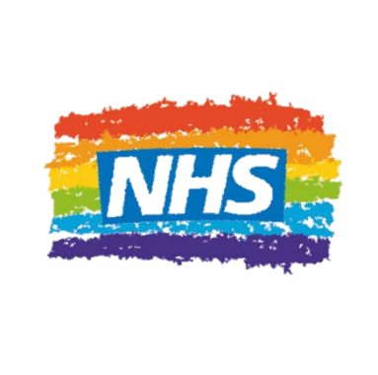

During 2023/2~~4~~ we continued to work to and review our progress against our Equality, Diversity and Inclusion Strategy 2021-2024. The key areas of work and actions are linked to and driven by:

* Equality, Diversity and Inclusion Workforce Steering Group
* Inclusion Networks
* The Workforce Race Equality Standard (WRES)
* The Workforce Disability Standard (WDES)
* Gender Pay Gap Reporting
* National Staff Survey results
* Quarterly People Pulse results
* Freedom to Speak Up
* Promotion of equality, diversity and inclusion to increase awareness and cultural competence across all colleagues groups

Our key achievements included:

***Our Networks***

* The expansion of our REACH (Race, Equality & Cultural Heritage) Network, DAWN (Disability and Wellbeing) Network, & PRIDE Network
* Appointments to the Senior EDI Specialist Role and UHN Head of OD&I Role
* Appointment of the EDI Patient Liaison Officer Role

Image of the enei Tide gold standard 2023

***Reward & Recognition***

* Achieved Gold Standard in the ENEI TIDE Benchmark
* Shortlisting of our EDI Network Chairs for Inclusive Practices Award at the UHN People Awards

***Cultural Calendar/Events***

* Celebration and promotion of key dates and events, pertaining to various communities and protected groups.
* Participation in a reverse mentoring programme as part of a System wide programme
* Organising a REACH Cultural Evening for REACH staff where System guest speakers and staff guest speakers could tell their stories, eat local/traditional meals and network with executive leadership.
* Having a stand at Northampton Pride/taking part in the Pride march as part of Pride Month.
* Fireside chats held for events such as Black History Month/Freedom to Speak Up Month, Disability History Month and LGBTQ+ History Month including speakers and feedback opportunities.

***Supporting our Staff***

* Ward rounds/visits to promote EDI and Freedom to Speak Up within the Trust.
* Development of Trans Inclusive Maternity training for NGH Maternity Services
* Having a successful bid for NHSE Funding for the national Gender Inclusion for Maternity Services Programme.
* Hosting the Anti-Racism Engagement sessions and engage with staff to shape our Anti-Racism strategy.
* Supporting Muslim Colleagues during Ramadan with an Iftar area, to allow space to eat, pray and seek reflection while at work.
* Purchasing and distribution of Sunflower Badges for colleagues with Hidden Disabilities
* Supported and reviewed the process around selecting a new Translation provider suitable for REACH & DAWN needs.
* Increased LGBTQ+ Training days by local provider Q Space to colleagues as well as Executive Level Leadership.
* First joint programme of work with the RCN aimed at Nursing Managers within Northamptonshire to deliver training session to reduce the risk of NMC Referrals
* The development of a joint approach with Kettering General Hospital

***Our Policies***

* Review and implementation of Cultural Ambassadors within the new Disciplinary Policy
* Creation and publication of the UHN Anti-Racism Toolkit
* Review and ratification of Group Transgender Workforce Policy
* Created Cultural Calendar for 2024

***Equality Delivery System***

* The Trust took part in the Equality Delivery System (EDS2022) review in December 2023 (Domain 3) and February 2024 (Domain 1). The EDS2022 is an improvement tool for patients, staff and leaders of the NHS to review and develop the approach in addressing health inequalities through three domains: Services, Workforce and Leadership. The tool measures Equality, Diversity and Inclusion performance in three Domains:
  + Domain 1 – Commissioned or provided services: The services reviewed were Chaplaincy and Diabetes. After reviewing the services an action plan has been created and is available on our website
  + Domain 2 – Workforce Health and Wellbeing
  + Domain 3 – Inclusive Leadership

***Tackling Racism:***

* Creation and publication of the UHN Anti-Racist Statement in October 2023

Our UHN co-produced antirasicm statement

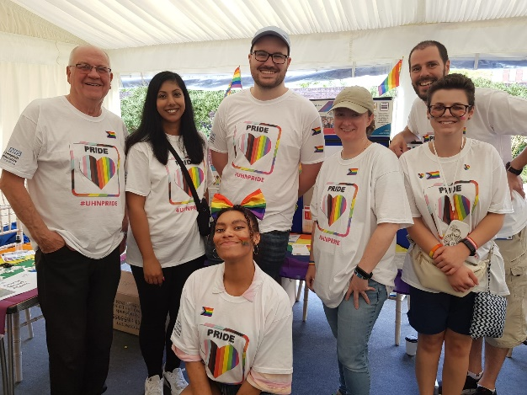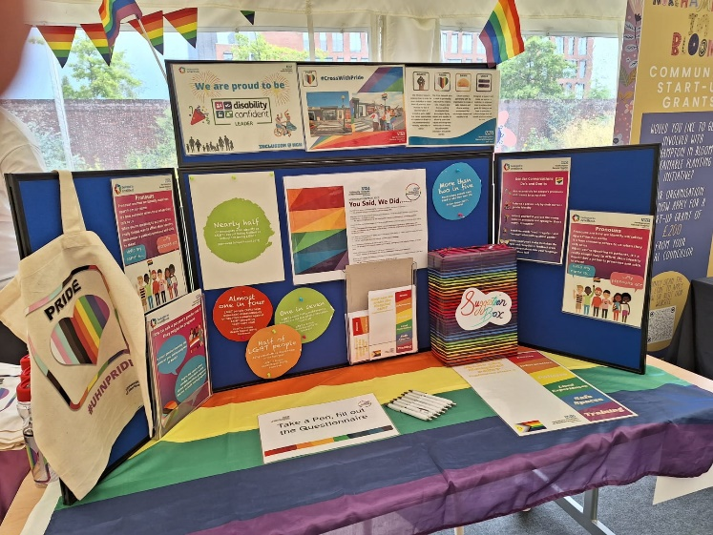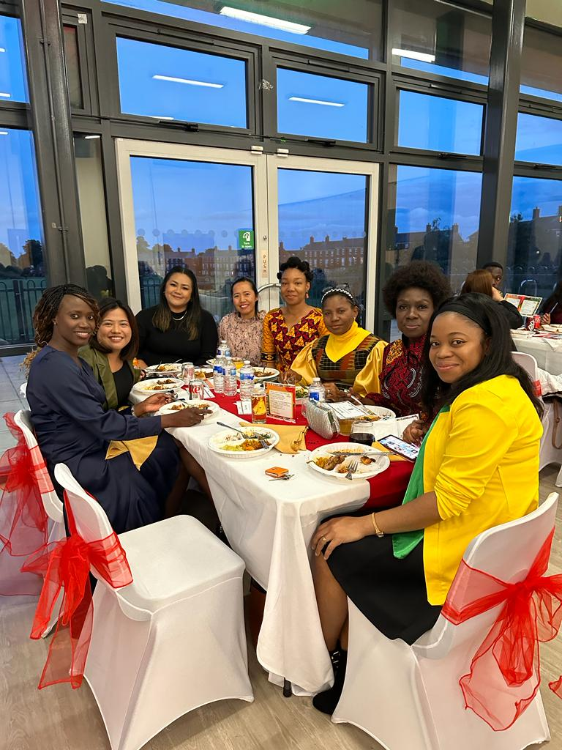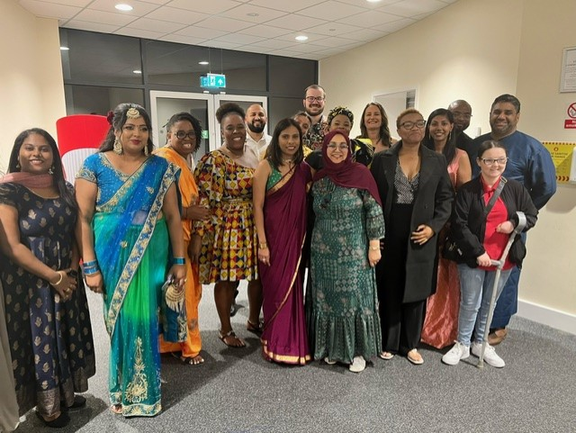

Photographs of colleagues at staff network events

Workforce Race Equality Standard (WRES)

We undertook the data analysis exercise for the National Workforce Race Equality Standard (WRES) in 2023 and compared these results to those of 2022 to establish if there had been improvements or deteriorations in the experiences or the treatment of BME colleagues when compared to our White colleagues.

We showed improvement in:

* The number of BME colleagues we employee
* The likelihood of BME colleagues entering the formal disciplinary process, when compared to White colleagues
* The likelihood of BME colleagues accessing non-mandatory training/Continuous Professional Development when compared to White Colleagues
* BME colleagues experiencing bullying, harassment or abuse from other colleagues in the last 12 months
* BME colleagues who have personally experienced discrimination at work from Manager/Team leader

Deteriorations were seen in:

* The likelihood of BME colleagues being appointed from shortlisting from shortlisting across all posts.
* BME colleagues experiencing bullying, harassment or abuse from patients, relatives or the public in the last 12 months.
* The percentage difference between our Board voting membership and our overall BME workforce.

There were no changes for:

* BME colleagues believing that Trust provides equal opportunities for career progression or promotion.

We acknowledge there is still work to do to improve the experiences and treatment of our BME workforce and we will be working closely with our REACH (Race, Ethnicity and Cultural Heritage) Inclusion Network to address the issues highlighted.

Our [WRES report](https://www.northamptongeneral.nhs.uk/About/Equality-and-diversity-information/Equality-Diversity-Inclusion.aspx) can be accessed via our website.

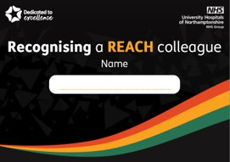

An image of the invite poster to the REACH Celebration Dinner An image of the Recognise a REACH colleague card

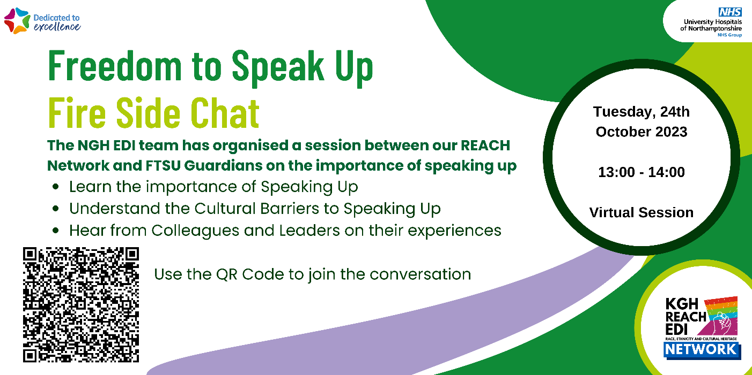

An image of a poster for a fire side chat session

Workforce Disability Equality Standard (WDES)

We undertook the data analysis exercise for the National Workforce Disability Equality Standard (WDES) in 2023 and compared these results to those of 2022 to establish if there had been improvements or deteriorations in the experiences or the treatment of disabled colleagues when compared to our non-disabled colleagues.

We showed improvement in:

* The number of disabled colleagues we employ
* Disabled colleagues experiencing bullying, harassment or abuse from other colleagues in the last 12 months
* The percentage of colleagues saying the last time they experienced harassment, bullying or abuse they or a colleague reported it

Deteriorations were seen in:

* Disabled colleagues experiencing bullying, harassment or abuse from patients, relatives or the public
* The likelihood of disabled applicants being shortlisted when compared to non-disabled applicants
* Overall engagement score for disabled colleagues
* The percentage of colleagues who have felt pressure from their manager to come to work despite not feeling well enough to perform their duties.
* The percentage difference between our Board voting membership and our overall disabled workforce, however despite this improvement our Trust Board does not reflect the overall workforce.

There were no changes for:

* The likelihood of disabled colleagues entering a formal capability process
* Disabled colleagues experiencing bullying, harassment or abuse from managers in the last 12 months
* The percentage of colleagues who believe the organisation provides equal opportunities for career progression
* The percentage of staff satisfied with the extent to which the organisation values their work.
* Percentage of colleagues with a long lasting health condition saying adjustments have been made to enable them to carry out their role.

We acknowledge there is still work to do to improve the experiences and treatment of our disabled workforce and we will be working closely with DAWN (Disability and Wellbeing Network) to address the issues highlighted.

Our [WDES report](https://www.northamptongeneral.nhs.uk/About/Equality-and-diversity-information/Equality-Diversity-Inclusion.aspx) can be accessed via our website.

Gender Pay Gap Reporting

As per the Gender Pay Gap Information Regulations 2017, we compiled and analysed our data and submitted it to the Government, as part of the requirements under the Regulations. Although we are not legally required to produce a written report, it was agreed this should be done to give context to the data and this will be published on our website.

In our organisation, women earn 95p for every £1 that men earn when comparing median hourly pay. This is an improvement from the previous year where it was 91p for every £1.

**Table showing Mean Hourly Rates, the difference and percentage pay gap, from 2022 to 2023**

|  |  |  |  |
| --- | --- | --- | --- |
|  | Mean Hourly Rate 2022 | Mean Hourly Rate 2023 | Mean Hourly Rate 2022/23 Variation |
| Male | £23.95 | £22.50 | -£1.45 |
| Female | £17.83 | £17.84 | +0.01 |
| Difference | £5.12 | £4.66 | -£0.46 |
| Pay Gap | 23.3% | 20.7% | -2.6% |

**Table showing Median Hourly Rates, the difference and percentage pay gap, from 2022 to 2023**

|  |  |  |  |
| --- | --- | --- | --- |
|  | Median Hourly Rate 2022 | Median Hourly Rate 2023 | Median Hourly Rate 2022/23 Variation |
| Male | £17.82 | £16.94 | -£0.88 |
| Female | £16.16 | £16.05 | -£0.11 |
| Difference | £1.66 | £0.88 | -£0.78 |
| Pay Gap | 9.3% | 5.2% | -4.1% |

We acknowledge there is a difference in the average pay of our male and female colleagues that needs to be addressed, which includes a greater female representation in our senior clinical roles.

Our [Gender Pay Gap report](https://www.northamptongeneral.nhs.uk/About/Equality-and-diversity-information/Equality-Diversity-Inclusion.aspx) can be accessed via our website.

Staff Survey 2023 Equality & Diversity Results

For 2023 Survey People Promise Themes ‘We are Compassionate and Inclusive we scored 7.15 out of 10. We are below the national average of 7.24.

We scored 7.96 for the sub score ‘Diversity and Equality’ and 6.84 for the sub score for ‘Inclusion’.

Underpinning this theme there are 4 questions from the Staff Survey that contribute to the overall ‘theme’ result, in relation to Diversity and Equality:

**Question 15** – *Does your organisation act fairly with regard to career progression/promotion, regardless of ethnic background, gender, religion, sexual orientation, disability or age?* There has been an improvement of 2.97% since 2022 and we are worse than the national average by 1.72%. The national average has improved by 0.2% since the 2022 survey.

**Question 16a** – *In the last 12 months have you personally experienced discrimination at work from patients/service users, their relatives or other members of the public?* There has been a deterioration 1.34% since 2022 and we are worse than the national average by 2.77%. The national average has deteriorated by 0.28% since the 2022 survey.

**Question 16b** –*In the last 12 months have you personally experienced discrimination at work from managers/team leaders or other colleagues?* There has been an improvement of 1.49% since 2022 and we are worse than the national average by 1.47%. The national average has improved by 0.51% since the 2022 survey.

**Question 21** – *I think my organisation respects individual differences (e.g. cultures, working styles, backgrounds, ideas etc.).* There has been an improvement of 5.87% since 2022 and we are worse than the national average by 0.94%. The national average has improved by 1.04% since the 2022 survey.

The survey has highlighted some areas of concern and we will be working with our colleagues, trades unions and Inclusion Networks to understand the specific issues behind the results so that we can work together to create an inclusive environment where all colleagues are respected and valued.

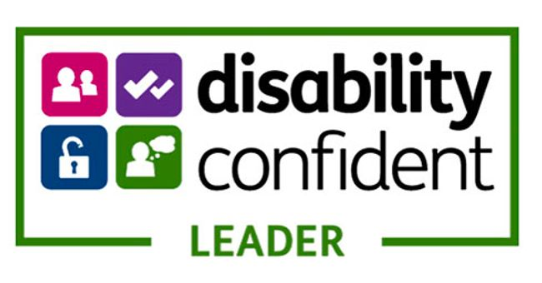

Logo for Disability Confident Leader

Logo for diverse, inclusive, together



Our Colleagues

The Trust employs 5442.35 whole time equivalent (wte) colleagues, a headcount of 6157 (as at 31 March 2024).

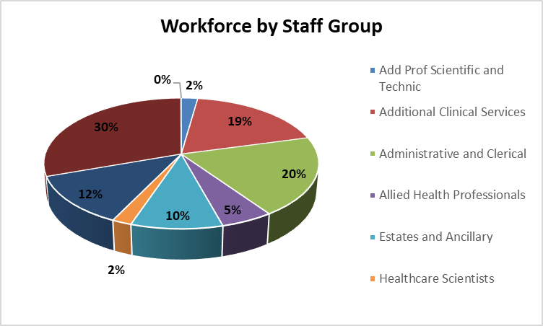

A graph to show the percentage split of the different staff groups within the organisation

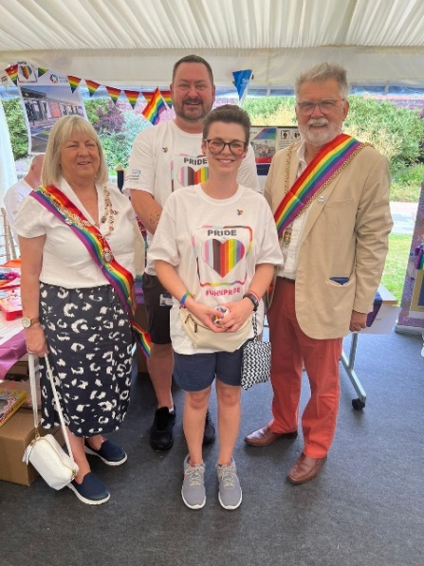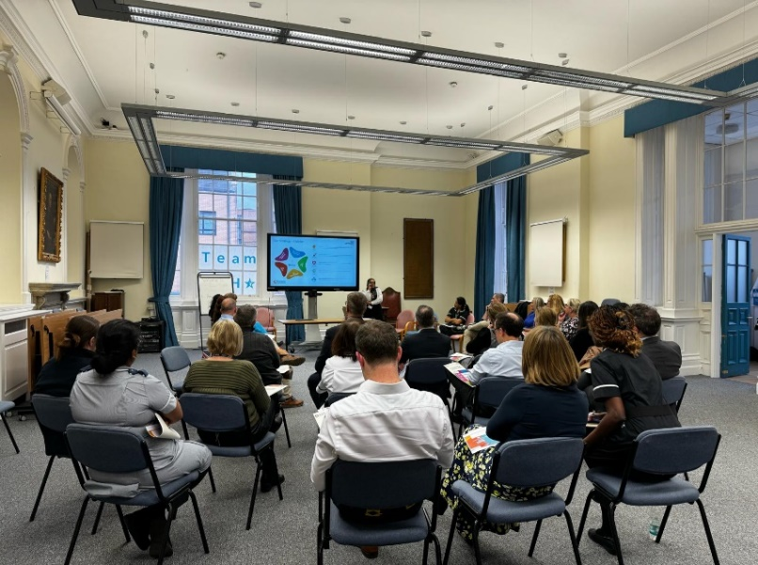

Photographs showing colleagues at events

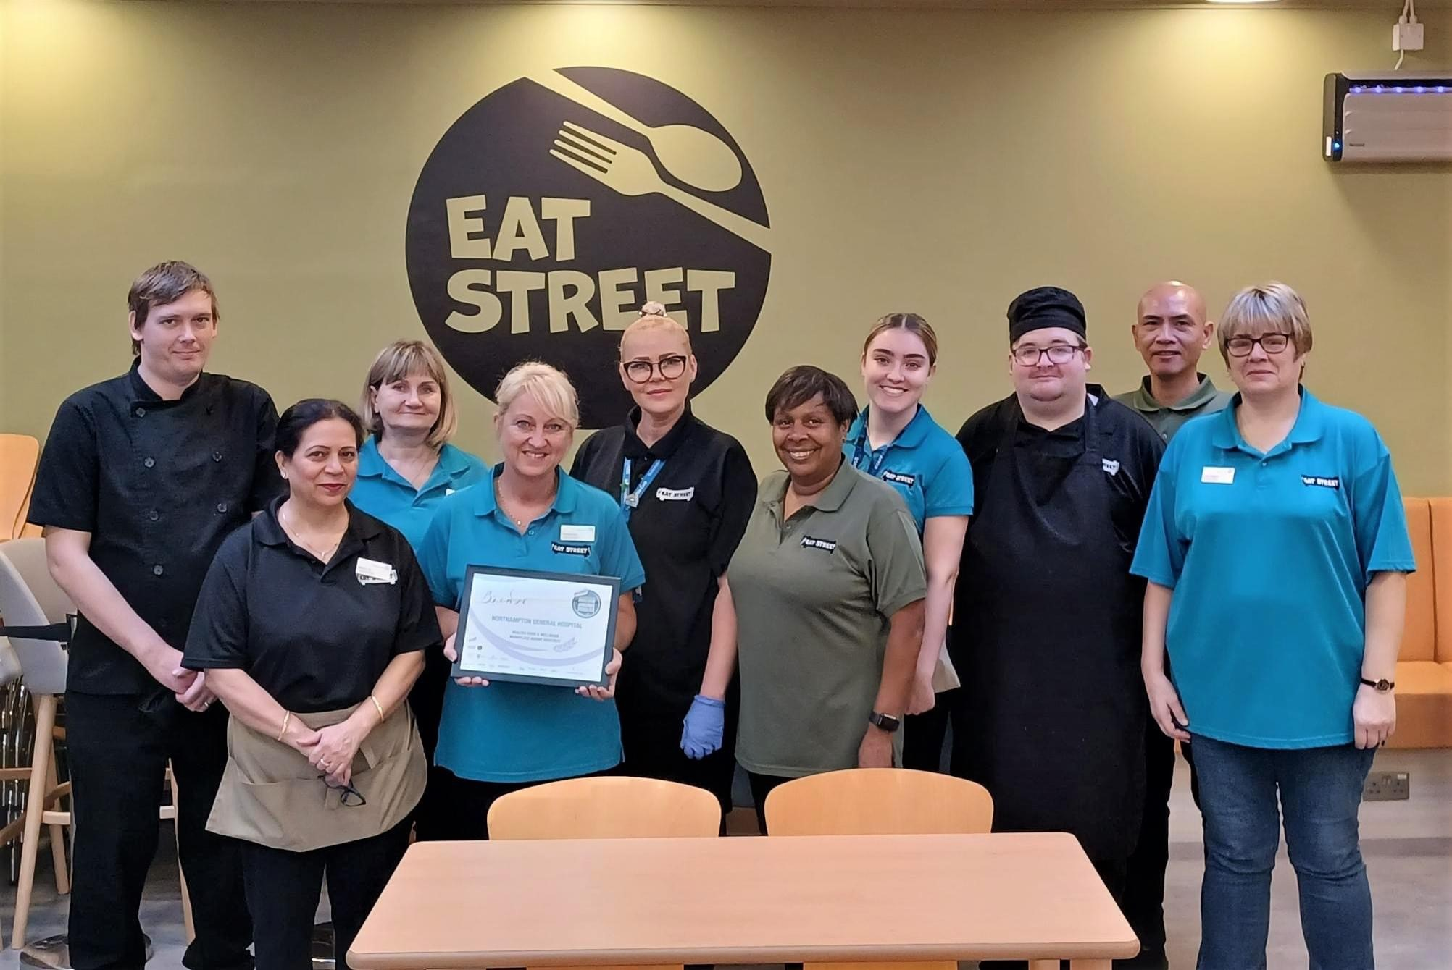

A photograph showing a group of colleagues

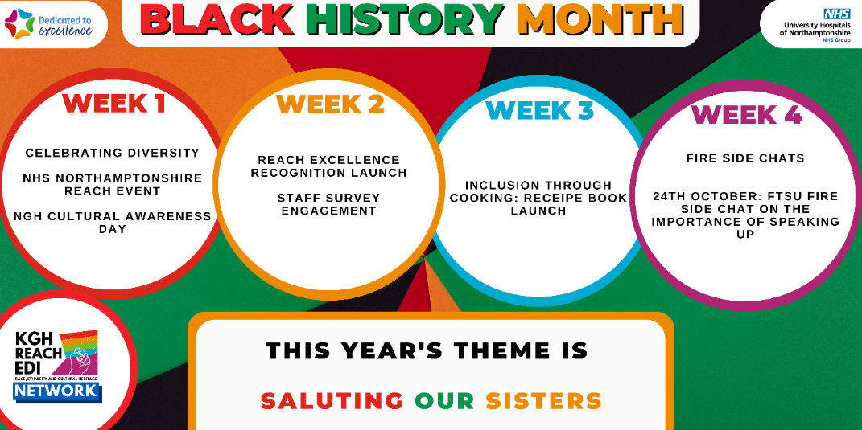

Image of a cultural calendar poster

|  |
| --- |
| **Age** |

The overall age profile for the Trust is shown in the chart below:

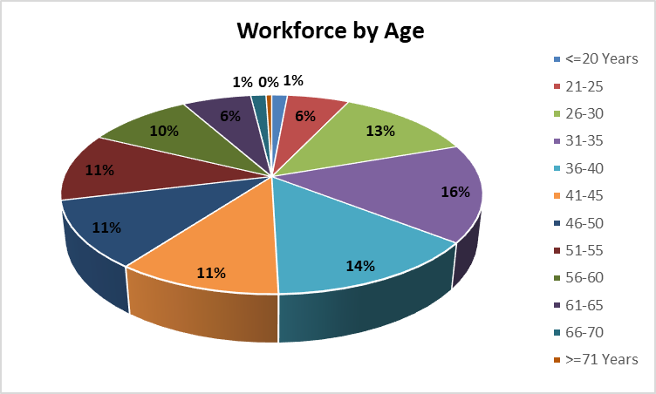

A graph to show the percentage split of colleagues within the organisation by age

|  |
| --- |
| **Disability** |

The overall disability profile for the Trust is shown in the chart below:

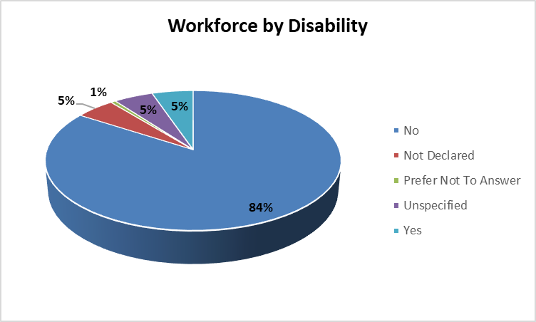

A graph to show the percentage split of colleagues within the organisation by disability

|  |
| --- |
| **Ethnicity** |

The overall ethnicity profile for the Trust is shown in the chart below:

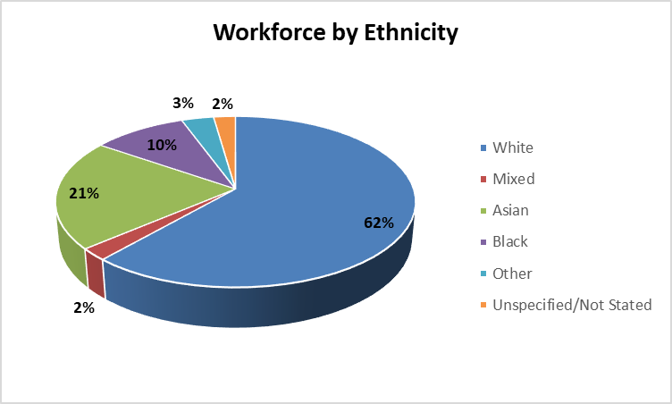

A graph to show the percentage split of colleagues within the organisation by ethnicity

|  |
| --- |
| **Marital Status** |

The overall marital status profile for the Trust is shown in the chart below:

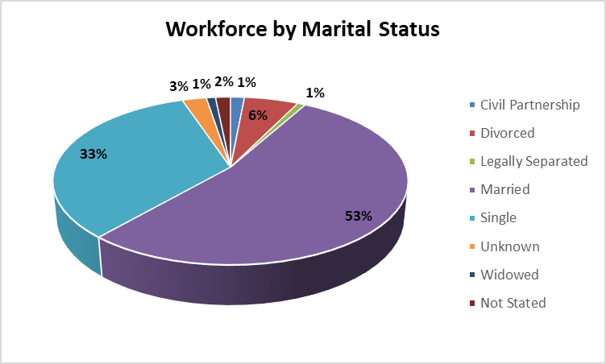

A graph to show the percentage split of colleagues within the organisation by marital status

|  |
| --- |
| **Religious Belief** |

The overall religious belief profile for the Trust is shown in the chart below:

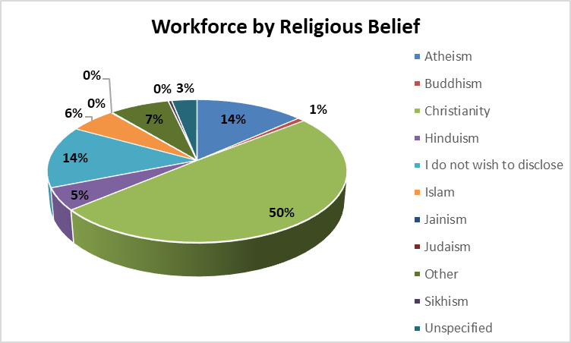

A graph to show the percentage split of colleagues within the organisation by religious belief

|  |
| --- |
| **Sex/Gender** |

The overall sex/gender profile for the Trust is shown in the chart below:

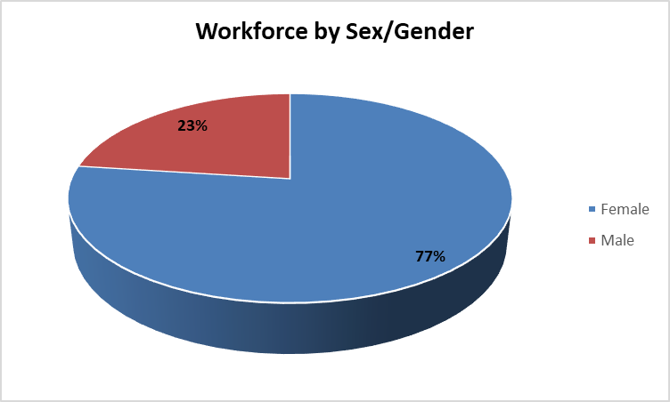

A graph to show the percentage split of colleagues within the organisation by sex/gender

|  |
| --- |
| **Sexual Orientation** |

The overall sexual orientation profile for the Trust is shown in the chart below:

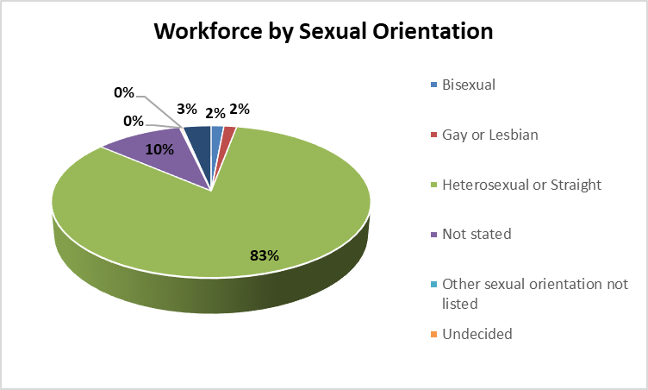

A graph to show the percentage split of colleagues within the organisation by sexual orientation

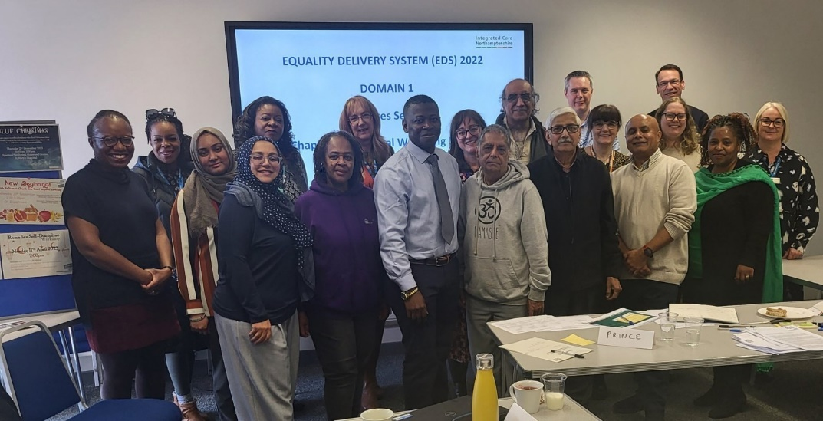

A photograph showing a group of colleagues

Northampton General Hospital NHS Trust

Our Contact Details are:

* Cliftonville, Northampton, NN1 5BD
* 01604 634700
* [www.ngh.nhs.uk](http://www.ngh.nhs.uk)
* Find us on Facebook
* Follow us on Twitter @nghnhstrust
* Follow us on Instagram

`