Gender Pay Gap Report 2020

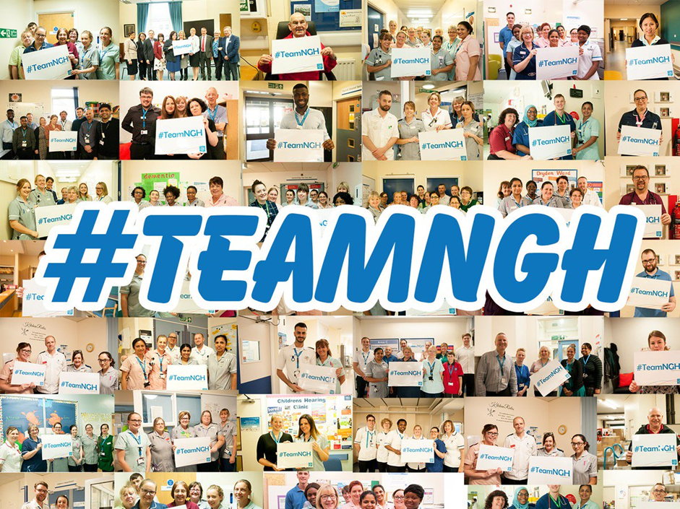

Introduction

In line with the Equality Act 2010 (Gender Pay Gap Information Regulations 2017), Northampton General Hospital NHS Trust has undertaken gender pay gap reporting on the snapshot date of 31 March 2019.

The Trust has calculated the following for its employees and workers:

- The mean gender pay gap
- The median gender pay gap
- The mean bonus gender pay gap
- The median bonus gender pay gap
- The proportion of males receiving a bonus payment
- The proportion of females receiving a bonus payment
- The proportion of males and females in each quartile pay band

At the time the snapshot was taken the Trust had 5507 employees/workers, of which 4360 (79.17%) were female and 1147 (20.83%) were male.

Compared to the 2018 report there has been little change in the overall number of staff at the Trust. The female workforce has decreased by 0.19% and the male workforce has increased by the same percentage.

The ratio of male to female staff that the Trust has is common place for an acute district general hospital such as Northampton. The greatest proportion of staff at the Trust are Nurses, Midwives and Healthcare Assistants.

The majority of these staff are female and this is supported by the number of registrants with the Nursing and Midwifery Council (NMC), who in their Diversity Data Report 2018-2019 reported that 89.3% of the registrants were female compared to 10.7% of males and 0.1% unknown.

NHS Pay Structure

The majority of staff at the Trust are on the national Agenda for Change Terms and Conditions of Service. The basic pay structure for these staff is across 8 pay bands and staff are assigned to one of these pay bands on the basis of job weight as measured by the NHS Job Evaluation Scheme. Within each band there are a number of incremental pay progression points as agreed by the NHS National Staff Council.

During 2018 The NHS Staff Council reached agreement on reform of the NHS Terms and Conditions of Service (Agenda for Change), resulting in a three-year pay deal, as well as reform of the pay structure and changes to terms and conditions. As a result the new pay structure increased starting salaries, reduced the number of pay points in each band and will shorten the amount of time it takes to reach the top of the pay band for most staff.

Medical and Dental staff have different sets of Terms and Conditions of Service, depending on seniority. However, these too are set across a number of pay scales, for basic pay, which have varying numbers of thresholds within them.

There are separate arrangements for Very Senior Managers, such as Chief Executives, Directors and other senior managers who are not on an Agenda for Change Terms and Conditions of Service.

As a public sector organisation, some of the services that are provided are on a 24/7 basis and therefore staff that work unsocial hours, participate in on-call rotas and work on general public holidays will also be in receipt of enhanced pay in addition to their basic pay. This mainly applies to clinical staff who work in ward areas along with non-clinical senior managers, who participate in the Senior Manager/Executive on-call rota and non-clinical staff who provide 24/7 services such as Estates and auxiliary staff.

The Trust does have a number of clinical departments that do not provide 24/7 such as clinics and outpatient areas and therefore these staff roles may not attract enhancements.

Mean Gender Pay Gap

The mean hourly rate is the average hourly wage across the entire organisation so the mean gender pay gap is a measure of the difference between women’s mean hourly wage and men’s mean hourly wage.

The 2019 mean gender pay gap for the Trust demonstrates that female staff are paid 30.1% less than male staff. This is an increase of 0.4% in the mean pay gap from the previous year as demonstrated in Table 1 below:

Table 1 - Mean Hourly Rates, the difference and percentage pay gap, from 2018 to 2019
 | Mean Hourly Rate 2018 | Mean Hourly Rate 2019 | Mean Hourly Rate 2018/19 Variation
Male | £22.54 | £23.43 | +£0.89
Female | £15.84 | £16.37 | +£0.53
Difference | £6.70 | £7.06 | +£0.36
Pay Gap | 29.7% | 30.1% | +0.4%

Median Gender Pay Gap

The median hourly rate is calculated by ranking all employees from the highest paid to the lowest paid, and taking the hourly wage of the person in the middle, so the median gender pay gap is the difference between women’s median hourly wage (the middle paid woman) and men’s median hourly wage (the middle paid man).

The 2019 median gender pay gap for the Trust demonstrates that female staff are paid 13.3% less than male staff. This is an increase of 4.4% in the median pay gap from the previous year, as demonstrated in Table 2 below:

Table 2 - Median Hourly Rates, the difference and percentage pay gap, from 2018 to 2019
 | Median Hourly Rate 2018 | Median Hourly Rate 2019 | Median Hourly Rate 2018/19 Variation
Male | £14.77 | £16.66 | +£1.89
Female | £13.36 | £14.44 | +£1.08
Difference | £1.41 | £2.22 | +£0.81
Pay Gap | 8.9% | 13.3% | +4.4%

Mean Bonus Gender Pay Gap

This calculation includes the bonuses that were paid to workers on the Clinical Nurse Bank who completed 150 hours of bank work. This is part of the Trust’s bonus loyalty scheme to increase the numbers of clinical bank workers and reduce the use of agency staff. Recipients of these bonuses are primarily Nurses, Midwives and Healthcare Assistants. It also includes any Clinical Excellence Awards (CEA’s) awarded to Consultants.

The 2019 mean bonus gender pay gap for the Trust demonstrates that female staff are paid 82.1% less than male staff. This is a decrease of 1.1% in the mean bonus gender pay gap from the previous year, as demonstrated in Table 3 below:

Table 3 - Mean Bonus Rates, the difference and percentage pay gap, from 2018 to 2019
 | Mean Bonus Rate 2018 | Mean Bonus Rate 2019 | Mean Bonus Rate 2018/19 Variation
Male | £6,323.21 | £6,610.44 | +£287.23
Female | £1,060.49 | £1,185.78 | +£1252.90
Difference | £5,262.72 | £5,424.66 | +£161.94
Pay Gap | 83.2% | 82.1% | -1.1%

Median Bonus Gender Pay Gap

The 2019 median bonus gender pay gap for the Trust demonstrates that female staff are paid 80.1% less than male staff. This is a decrease of 5% in the median bonus gender pay gap from the previous year, as demonstrated in Table 4 below:

Table 4 - Median Bonus Rates, the difference and percentage pay gap, from 2018 to 2019
 | Median Bonus Rate 2018 | Median Bonus Rate 2019 | Median Bonus Rate 2018/19 Variation
Male | £3,015.96 | £3,015.96 | £0
Female | £450.00 | £600.00 | +£150
Difference | £2,565.96 | £2,415.96 | -£150
Pay Gap | 85.1% | 80.1% | -5%

Proportion of Males and Females Receiving a Bonus Payment

Of the total workforce eligible for bonuses (Consultants in receipt of CEA payments and those registered as workers on the Clinical Nurse Bank), 12% of males received bonuses compared to 16.7% of females. This is an increase of 0.5% and 1.6% respectively, as demonstrated in Table 5 below:

Table 5 – Proportion of Males and Females Receiving a Bonus Payment from 2018 to 2019
 | Bonus Rate 2018 | Bonus Rate 2019 | Bonus Rate 2018/19 Variation
Male | 11.5% | 12% | +0.5%
Female | 15.1% | 16.7% | +1.6%
Difference | 3.6% | 4.7% | +1.1%

Proportion of Males and Females in Each Quartile Pay Band

At the time the snapshot was taken the percentage of female staff was 79.17% and the percentage of male staff was 20.83%.

As shown in Table 6, below, the percentage of females in the lower, lower middle and upper middle quartiles is greater than the male percentage and sitting above the Trust split. There is a significant reduction of in females in the upper quartile.

Table 6 – Proportion of Males and Females in Each Quartile Pay Band from 2018 to 2019
Quartile | 2018 |  |  | 2019
 | Gender | Number | % | Gender | Number | %
Lower | Male | 281 | 20.4% | Male | 273 | 19.8%
 | Female | 1096 | 79.6% | Female | 1103 | 80.2%
Lower Middle | Male | 226 | 16.4% | Male | 235 | 17.1%
 | Female | 1151 | 83.6% | Female | 1142 | 82.9%
Upper Middle | Male | 187 | 13.6% | Male | 200 | 14.5%
 | Female | 1190 | 86.4% | Female | 1177 | 85.5%
%Upper | Male | 443 | 32.1% | Male | 439 | 31.9%
 | Female | 935 | 67.9% | Female | 938 | 68.1%

Further Analysis

In relation to the mean and median gender pay gaps further analysis shows that the greatest impact on the gap falls within Consultant workforce that attracts the highest hourly rates as shown below in Table 7 and 8 and has a greater number of male staff than female staff within them.

Other Medical and Dental Staff also have a significant gender pay gap and for the median calculation only the gap for Very Senior Managers is also significant, however this staff group has more female staff than male staff within it

The only group of staff where the pay gap calculation shows that the female workforce (74%) is paid more than the male workforce (16%) is Agenda for Change Bands 1-7 at + 8.1% for the mean calculation and +12.1% for the median calculation.

Table 7 – Split of Mean Gender Pay Gap by Staff Groups
 | Consultants |  | Other Medical & Dental |  | Agenda for Change Bands 8a – 9 |  | Very Senior Managers |  | Agenda for Change Bands  1-7
Male | £62.42  (160) | -11.5% | £26.94  (172) | -7.9% | £27.38  (50) | -2.6% | £55.81  (9) | -2.2% | £13.74  (756) | +8.1%
Female | £55.25  (70) |  | £24.81  (141) |  | £26.66  (155) |  | £54.60  (14) |  | £14.85  (3980)
(Number of staff in group)

Table 8 – Split of Median Gender Pay Gap by Staff Groups
 | Consultants |  | Very Senior Managers |  | Other Medical & Dental |  | Agenda for Change Bands 8a – 9 |  | Agenda for Change Bands  1-7
Male | £58.83  (160) | -14% | £51.70  (9) | -12% | £25.16  (172) | -6.3% | £26.17  (50) | -2.4% | £12.01  (756) | +12.1%
Female | £50.61  (70) |  | £45.48  (14) |  | £23.57  (141) |  | £25.55  (155) |  | £13.47  (3980)
(Number of staff in group)

The graph below further demonstrates that the gap between the numbers of female staff to male staff starts to lessen from the hourly rate of £30 per hour and above and at £50 per hour and above the number of males becomes greater than the number of females.
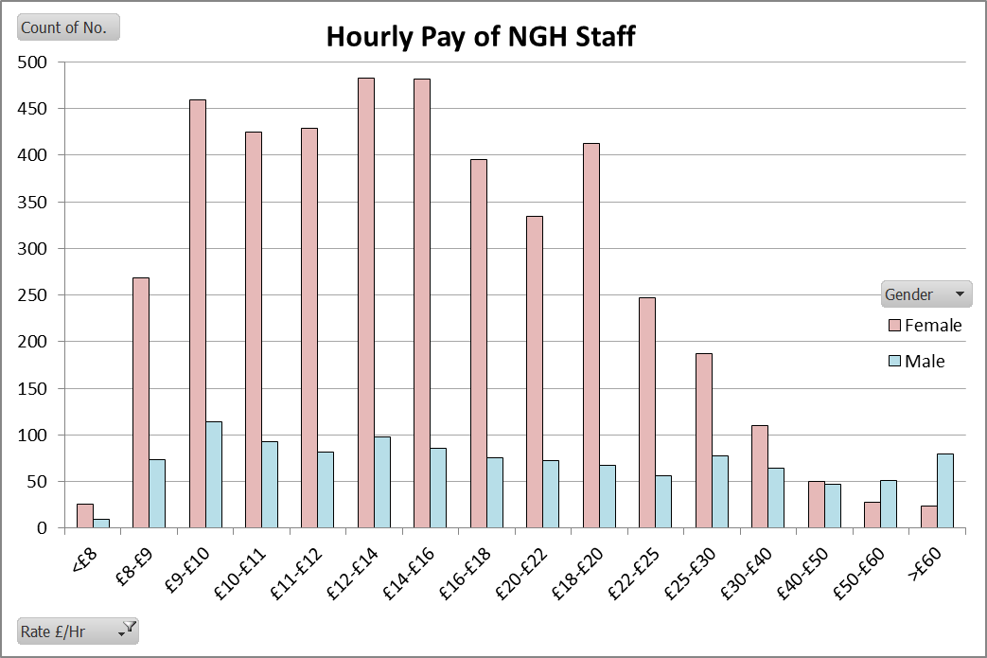

The reduction in increments with the Agenda for Change pay scales, as part of the 2018 Pay Deal, may have also impacted the overall results, especially in the median gender pay gap calculation, as this year it has resulted in the female median calculation falling into the lower part of the Band 5 pay range whereas the male calculation falls within the upper part of the pay range for Band 5.

The calculation for the proportion of males and females receiving a bonus payment shows that of the 883 staff who received a bonus, 103 of those were Consultants receiving a Clinical Excellence Award (CEA). Of these 103 Consultants, 82 were male (80%) and 21 were female (20%). The average CEA payment calculation was £10,411 for males compared to £10,161 for females, resulting in a gap in bonus pay of £250 for Clinical Excellence Awards.

Findings

The Trust acknowledges that there could be greater female representation in its senior clinical roles, however the available consultant workforce has a greater proportion of males to females across the NHS, which limits the pool of available applicants to these types of roles.

Over the recent years the Trust has been developing leadership development training to strengthen the skills of its existing staff to support career development within the organisation. During 2018 two key programmes were launched and these continue to assist with the career development of female staff into more senior clinical and also non-clinical management roles within the organisation.

Likewise the Trust acknowledges that there could be greater male representation in less senior roles, both clinical and non-clinical, however again there are some limitations due to the pool of available applicants and an example of this is male Nurses and Midwives.
The Trust has a robust recruitment process that has equality and diversity embedded into its processes. The Trust will continue to recruit in a non-gender biased manner to ensure that adverts and applicants are recruited in a fair, open and transparent manner.

During future Clinical Excellence Awards rounds the Trust will monitor the gender of the applicants together with those that are successful. In addition The Trust will ensure that all the panel members are trained in equality and diversity.

The Trust will take the findings of this report to the Equality and Diversity Staff Group and actions will be agreed and included in the Trust’s Equality and Diversity Plan/Objectives.

