**Workforce Disability Equality Standard (WDES) Data**

**Percentage of staff members at NGH who are disabled, non-disabled or have not stated their disability status**

*Total Workforce = 5805*

*Disabled = 238*

*Non-Disabled = 4791*

*Not stated = 776*

**AFC Bands**

**Medical & Dental**

**Disabled Non-Disabled Not Stated**

1-4 **4.96% 82.60% 12.44%**

5-7 **3.68% 83.09% 13.23%**

8A-8D **3.47% 80.69% 15.84%**

9-VSM **8% 80% 12%**

**Disabled Non-Disabled Not Stated** Consultants  **3.09% 69.50% 27.41%**

Career Grade  **0.55% 88.46% 10.99%**

Trainee Grades  **3.93% 88.21% 7.86%**

2022

**Percentage of staff who believe that their organisation provides equal opportunities for career progression or promotion**

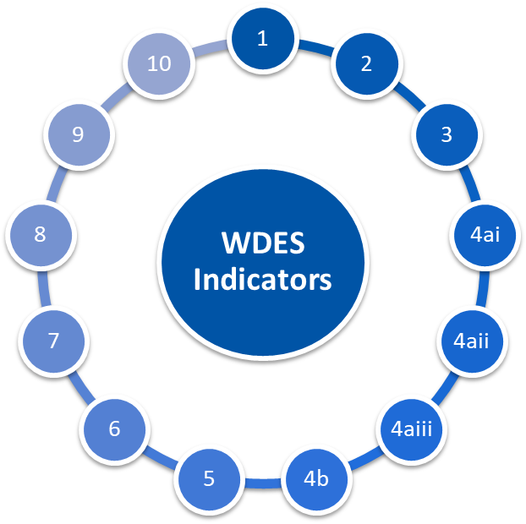

**1.24**

**0.12 Deterioration**

**Disabled 51% Non-Disabled 52%**

**Improvement of 2%**

**Disabled -4.10% Non-Disabled 17.47%**

**Improvement of**  0.90%

**Percentage difference between the organisations’ Board voting membership and its overall workforce**

**Relative likelihood of non-disabled staff compared to Disabled staff being appointed from shortlisting across all posts**

**Engagement score for disabled staff compared to non-disabled and overall engagement score out of 10**

**Disabled 6.4 Non Disabled 6.8 Overall 6.7**

**Deterioration of 0.3**

**o**

**Relative likelihood of Disabled staff entering the formal capability process compared to non-disabled staff**

**0**

**Improvement of 5.85**

**Disabled 33%**

**Non Disabled 28%**

**Improvement of 2%**

**72%**

**Deterioration of 7%**

**Percentage of staff with a long lasting health condition or illness saying their employer has made adequate adjustment(s) to enable them to carry out their work**

**Percentage of staff experiencing harassment, bullying or abuse from patients, relatives or the public in last 12 months**

**Disabled 23%**

**Non Disabled 14%**

**Deterioration of 2%**

**Percentage of staff experiencing harassment, bullying or abuse from manager in last 12 months**

**Disabled 33% Non-Disabled 39%**

**Deterioration of 3%**

**Percentage of staff satisfied with the extent to which their organisation values their work**

**Disabled 33%**

**Non Disabled 22%**

**Deterioration of 2%**

**Disabled 33% Non-Disabled 25%**

**Improvement of 2%**

**Percentage of staff who have felt pressure from their manager to come to work, despite not feeling well enough to perform their duties**

**Percentage of staff experiencing harassment, bullying or abuse from other colleagues in last 12 months**

**Disabled 45%**

**Non Disabled 43%**

**Deterioration of 5%**

**Percentage of staff saying that the last time they experienced harassment, bullying or abuse at work, they or a colleague reported it**

1

**Work with disabled staff and the Disability and Wellbeing Network (DAWN) to better understand the reasons why colleagues may not have declared a disability on ESR, with a view to closing the gap between ESR and National Staff Survey declaration rates**

We will work to provide staff with psychological safe space to explore reasons why they are reluctant to declare disability/long-term conditions and use the opportunity to provide staff with reasons why information is collected and how the information is used and that their personal data is kept safely and remains confidential.

**Workforce Disability Equality Standard (WDES) Data**

2022-24

**Reduce the number of disabled colleagues experiencing harassment, bullying and abuse from patients/public and staff.**

Working with disabled staff and our DAWN colleagues, we will:

1. Discuss experiences of harassment, bullying or abuse with disabled staff, ensuring that there is a safe person/space for any discussions
2. Launch a communications campaign focussed on reducing harassment, bullying and abuse
3. In conjunction with unions, freedom to speak up guardians, and staff networks, review and improve support for staff who experience bullying, harassment or abuse. This will include access to specialist support for staff who harassment, bullying and abuse including SOS team, Stronger Together and Safeguarding teams.
4. Working with system colleagues and DAWN members, review NHS England’s Civility and Respect toolkit and adopt identified practices set out

2

3

**Work with disabled staff and other partners to improve the management of workplace adjustments**

1. Review the reasonable adjustments good practice published by NHS Employers
2. Introduce workplace adjustments passports, which enable disabled staff to record and share the details of the reasonable adjustments they need at work.
3. With system partners, review reasonable adjustments policies to ensure Group and system-alignment with national good practice examples
4. Explore the introduction of a centrally funded budget to enable managers to purchase any equipment required for reasonable adjustments

4

**Deliver the ‘Dedicated to Excellence’ Culture and Leadership Programme, ensuring diverse representation from across the Group to build psychological safety and ensure all staff voices are heard**