**Relative likelihood of White staff being appointed from shortlisting compared to BME staff**

**Relative likelihood of BME staff entering the formal disciplinary process compared to White staff**

**Percentage of staff experiencing harassment, bullying or abuse from other colleagues in the last 12 months**

**Percentage of staff experiencing harassment, bullying or abuse from patients, relatives or the public in the last 12 months**

**Relative likelihood of White staff accessing non-mandatory training and CPD compared to BME staff**

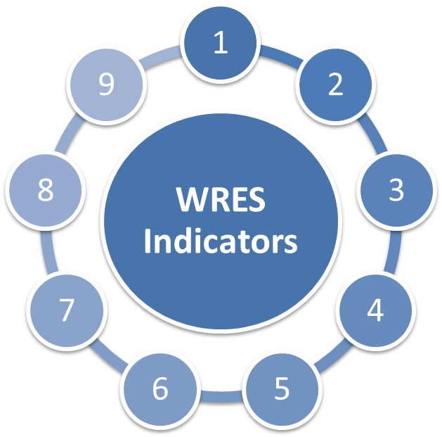

**0.7**

**Deterioration of 0.27 since 2022/23**

**0.17**

**Deterioration of 0.3 since 2022/23**

**0.93**

**An improvement of 0.03 in comparison to 2022/23**

**BME -23%**

**White 25%**

**Unchanged from the previous year**

**BME 14%**

**White 9%**

**5% improvement for BME staff and 1% deterioration for White staff**

**BME 51%**

**White 56%**

**11% improvement for BME staff**

**BME 24%**

**White 25%**

**6% improvement for BME staff**

**BME 30%**

**White 26%**

**2% improvement for BME staff**

**Percentage difference between the organisations’ Board voting membership and its overall workforce**

**Percentage of staff who have personally experienced discrimination at work from Manager/Team leader**

**Percentage of staff believing the hospital provides equal opportunities for career progression or promotion**

**White BME Not Stated**

Consultants 42.96% 54.93% 2.11%

Senior Medical Manager 33.33% 33.33% 33.33%

Non-Consultant Career Grade 15.60% 80.73% 3.67%

Trainee Grades 21.71% 73.64% 4.65%

**White BME Not Stated**

Bands 1-4 74.38% 23.54% 2.08%

Bands 5-7 56.35% 41.33% 2.32%

Bands 8A-VSM 81.09% 17.95% 0.96%

**Percentage of staff members at NGH who are White, BME or have not stated their ethnicity.**

*Total Workforce = 6158*

*White = 3782*

*BME = 2235*

*Not stated = 141*

**AFC Bands**

**Medical & Dental**

**Workforce Race Equality Standard (WRES) Data 2023-24**

**What are we doing / plan to do within the hospital:**

**Specific Board Actions:**

Continue the Mentoring Programme and expand participants to other protected groups whilst retaining a significant percentage of REACH staff, Board Members to invite their mentor to Board to expand learning for all Board Members.

1

1

To streamline the Inclusive Recruitment Champion process to ensure that our recruitment and selection process is not only effective but also sustainable

Take supportive action to increase the diversity of the Board across the Group.

Expansion of Executive Sponsorship to include Non-Exec Directors as Sponsors for all Networks and continue to retain the engagement of the Exec Sponsors for the Networks.

Inclusion of a protected group role model staff story at Board meetings so viewers in those groups can relate.

Commitment to support EDI Steering Group as our new assurance framework for colleagues.

Roll out Tackling Racism Toolkit and create Rethinking Racism Education Programme and Microaggressions Toolkit to embed cultural change within organisation whilst creating a safe space for protected groups

Promote REACH Network Drop In Service to create a safe space for Network members to share feedback on activities or raise cultural issues/concerns to a respective Co-Chair of the Network in confidence. Provide support to those members who need it.

Amplify REACH voice through a single UHN REACH network that supports REACH colleagues in all staff groups

Align FTSU and EDI compassionate walks and conversations to encourage REACH colleagues to seek early support or raise concerns in a psychologically safe environment.

To strengthen the RCN Cultural Ambassador programme to support REACH staff during formal and informal HR process to ensure a space/ atmosphere of safety, transparency and support that is offered to the staff.

2

3

4

Commitment to a Board Development Session to continue to focus on DiversCommitment to a Board Development Session to continue to focus

on Diversity & Inclusion. To include Rethinking Racism Education

Programme

king Racism Education Programme

5

6

5

4

3

2

6